

Standard Award Process
For
Illinois Funding Agencies

Table of Contents

Table of Contents 1
Version History 4
Document Purpose 4
Basic Navigation 5
GATA Systems and Master Data 6
License Information and Account Settings 6
License Information and Account Settings Considerations 7
Award Activation - NOSA 7
Departments 8
Subjects 9
Users 11
Custom Budget Categories 13
Purpose Areas 14
Award Workflow Considerations 17
Enroll Award into Workflow 17
Access Workflows 18
Create Workflows 19
Configure Workflows Queues 20
Configure Workflow Action Items 22
Workflow Considerations 24
Additional Workflow Resources 24
Award Creation 25
Award Pre-Requisites 25
Create Award Through Workflow 25
Award Details 28
General Award Information 28
Configure Award Details 29
Uniform Grant Agreement 31
General Uniform Grant Agreement Information 31
Uniform Grant Agreement Custom Form Considerations 34
Award Settings 35
Configure Grant Settings 35
Configure Performance Plan Settings 37
Configure Budget Settings 38
Post-Award Performance Plan 41
Copy Pre-Award Performance Plan to Post-Award 41
Access Post-Award Performance Plan 42
Create Performance Plan Goal 44
Post-Award Budget 46
Copy Pre-Award Budget to Post-Award 46
Access Post-Award Budget 47
Create and Update Budget Categories 48
Create and Update Budget Line Items 51
Create Uniform Grant Agreement Report 55
Pre-Requisites and Best Practice 55
Create ERP Contract 58
Pre-Requisites and Best Practice 58
Additional ERP Resources 60
Award Activation 62
Monitoring and Reporting 63
Activity Center 63
Workflow Task Completion and Item History 64
Review Award Details 65
Analytics 65
Tools and Custom 66
Standard Reports 66
Customer Support 68
Housekeeping Tips 68
AmpliFund Links 68
AmpliFund Support Contacts 68
GATU Support Contacts 68
Glossary 69

Version History
Version Number | Date | Author | Modifications
v0.1 | 07/30/2024 | AmpliFund  T. Colgrove | Initial Draft
v1.0 | 8/30/24 | AmpliFund T. Colgrove | Initial Publication
V1.1 | 12/6/24 | AmpliFund T. Colgrove | Formatting and Product Updates

Document Purpose
This document serves two primary purposes:
- Provide a comprehensive guide to standard Award processes within AmpliFund, covering key terms, basic navigation, detailed step-by-step instructions, and essential considerations.
- Offer Illinois Funding Agencies a flexible documentation framework that can be seamlessly adapted to include specific Agency programmatic requirements.
We encourage Agencies to consolidate their programmatic materials, review the standard documentation provided, and tailor it to meet their unique needs.
This document will be updated regularly to incorporate product enhancements, feature releases, and additional best practices as defined by the State or in support of compliance and reporting requirements.
Contact your AmpliFund implementation team to assist with drafting customized documentation that aligns your Agency’s objectives.

Basic Navigation
- Left Navigation Menu – The left navigation menu is on left side every page is how you will access most records in AmpliFund. For example, access Grants via the Grants Management Tab and Users via the Administration > System Security tab.
- Options Toolbar – The Options Toolbar is on the top right of every page offering configuration icons based on the page you are on. For example, when entering an Achievement, there will be a + icon on the top right of the screen in the Options Toolbar.
- User Information – User Information can be accessed via the dropdown next to your name on the top right of the screen. Here you can review the Terms and Conditions, submit a Support Ticket, access the Applicant Portal, and more.
Learn more about Basic Navigation here - https://il-amplifund.zendesk.com/hc/en-us/article_attachments/360059011294
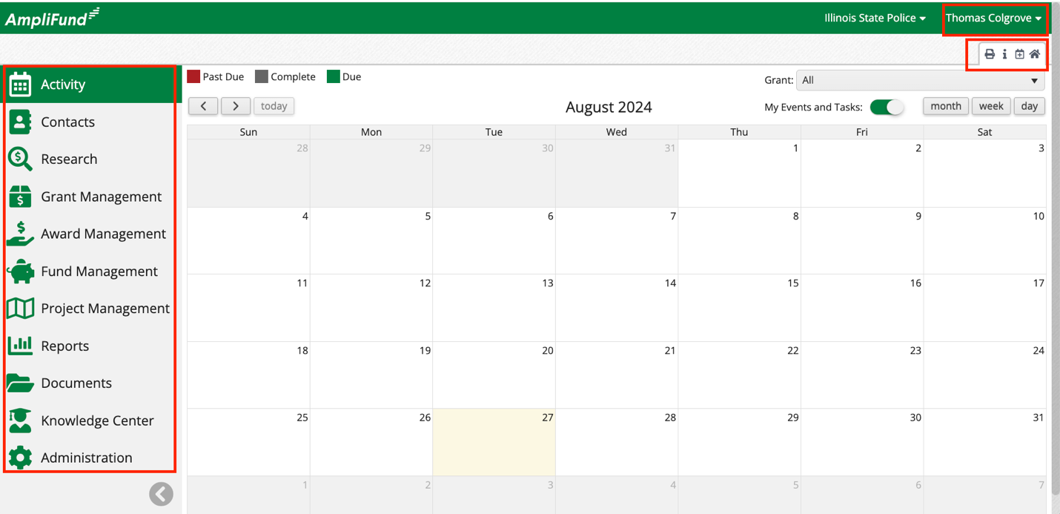

GATA Systems and Master Data

License Information and Account Settings
License information and account settings can be viewed and updated by funding agencies. Some information and settings can only be updated in the GATA Grantee Portal.
Complete the following steps to access, review, and update the License Information.
- Click on Administration > License Information.
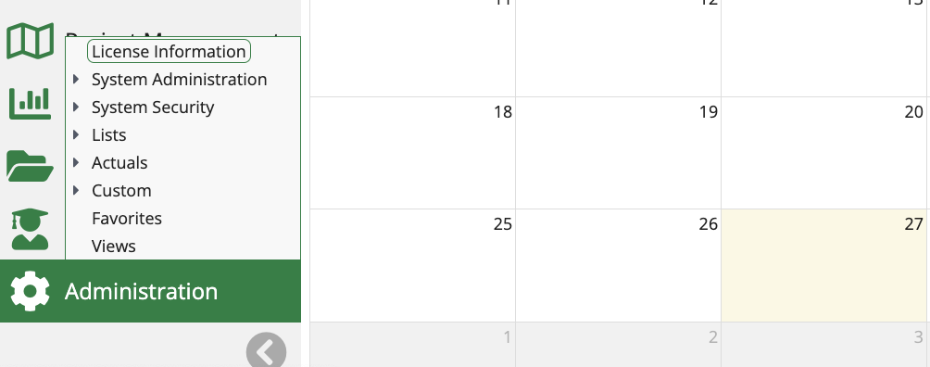
- Review License Information.
- Click on the pencil edit icon on the top right of the screen to update.
- Click Update on the bottom right of the screen.
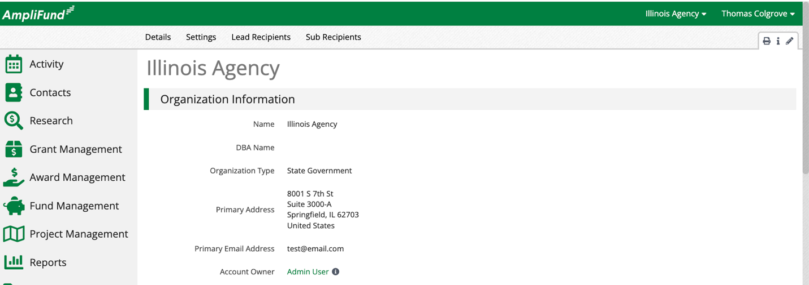
Complete the following steps to access, review, and update the Account Settings.
- Form the Licenses Information page, click on Settings across the top of the screen.
- Review Settings.
- Click on the pencil edit icon on the top right of the screen to update.
- Click Update on the bottom right of the screen.
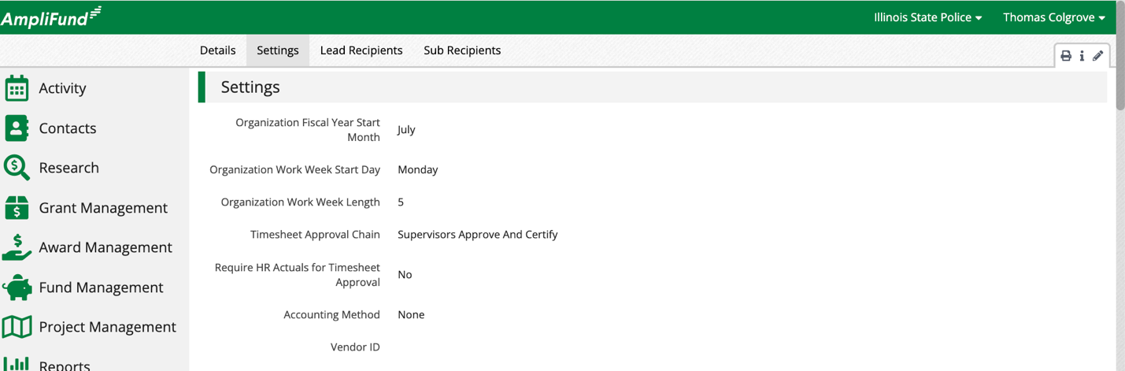

License Information and Account Settings Considerations
Funders can update License Information Details and Settings in AmpliFund. Recipients must update the information in the GATA Grantee Portal.

Award Activation - NOSA
There is an integration between the CSFA (Catalog of State Financial Assistance) and AmpliFund that streamlines the process. It works as follows: The funder first creates a program in the CSFA. This information is then pulled into AmpliFund when setting up the NOFO/NDFI (Opportunity). Funders can then review and select Applications to Award, and Applicants are notified of any changes to their Application Status. Once an Award is Activated in AmpliFund, the details are automatically transferred back to the CSFA. Grantees are informed of the Award Details and can access their Award by logging into AmpliFund. This integrated approach replaces the old NOSA process.

Departments
Departments can be used to link User, Grant, and Projects adding level of access and security. The Department Admin, User (Salary), and User (No Salary) security roles have access to any record linked to their departments. Departments must be added to the Opportunity when creating or editing the object in AmpliFund.
Complete the following steps to access, update, and create Departments.
- Click on Administration > System Security > Departments.
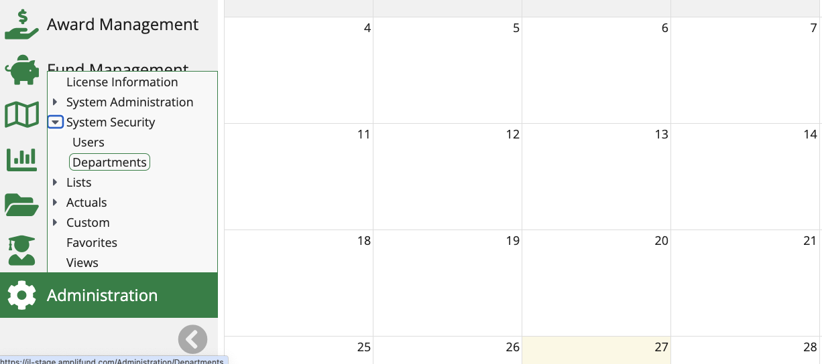
- Click the pencil icon to update.
- Click on the paper icon to copy.
- Click on the trashcan icon to delete.
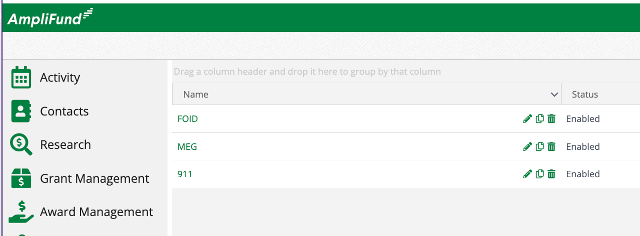
- Click on the + icon on the top right of the screen to add a new Department.
- Enter the Name.
- Enter the Description (optional).
- Click Create on the bottom right of the screen.
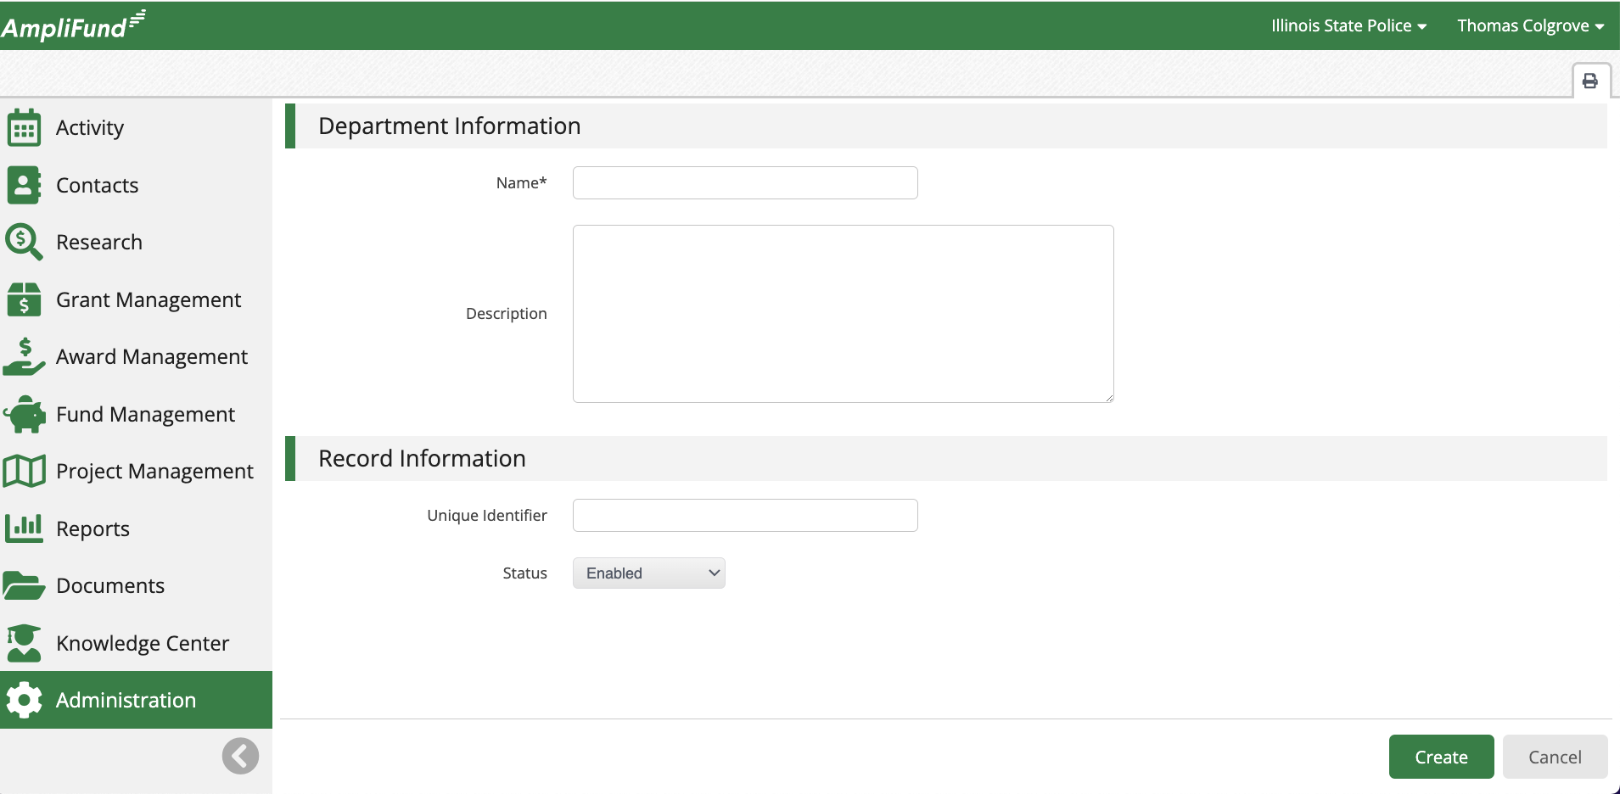

Subjects
Subjects are keywords that link Grant and Project records. By including subjects, your Grants and Projects can be more searchable and manageable.
Complete the following steps to access, update, and create Subjects.
- Click on Administration > Lists > Subjects.
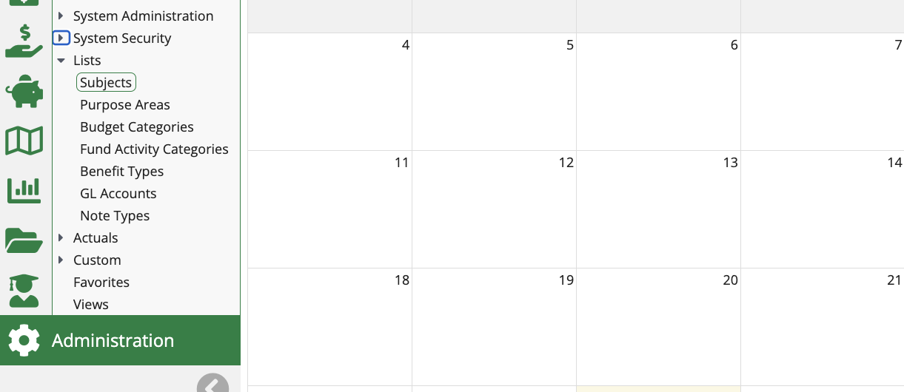
- Click the pencil icon to update.
- Click on the trashcan icon to delete.
- Click on the + icon on the top right of the screen to add a new Subject.
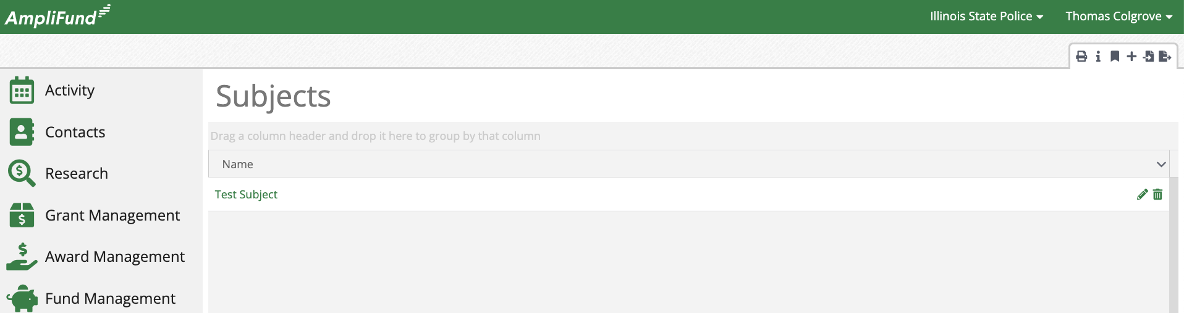
- Enter the Name.
- Click Create on the bottom right of the screen.
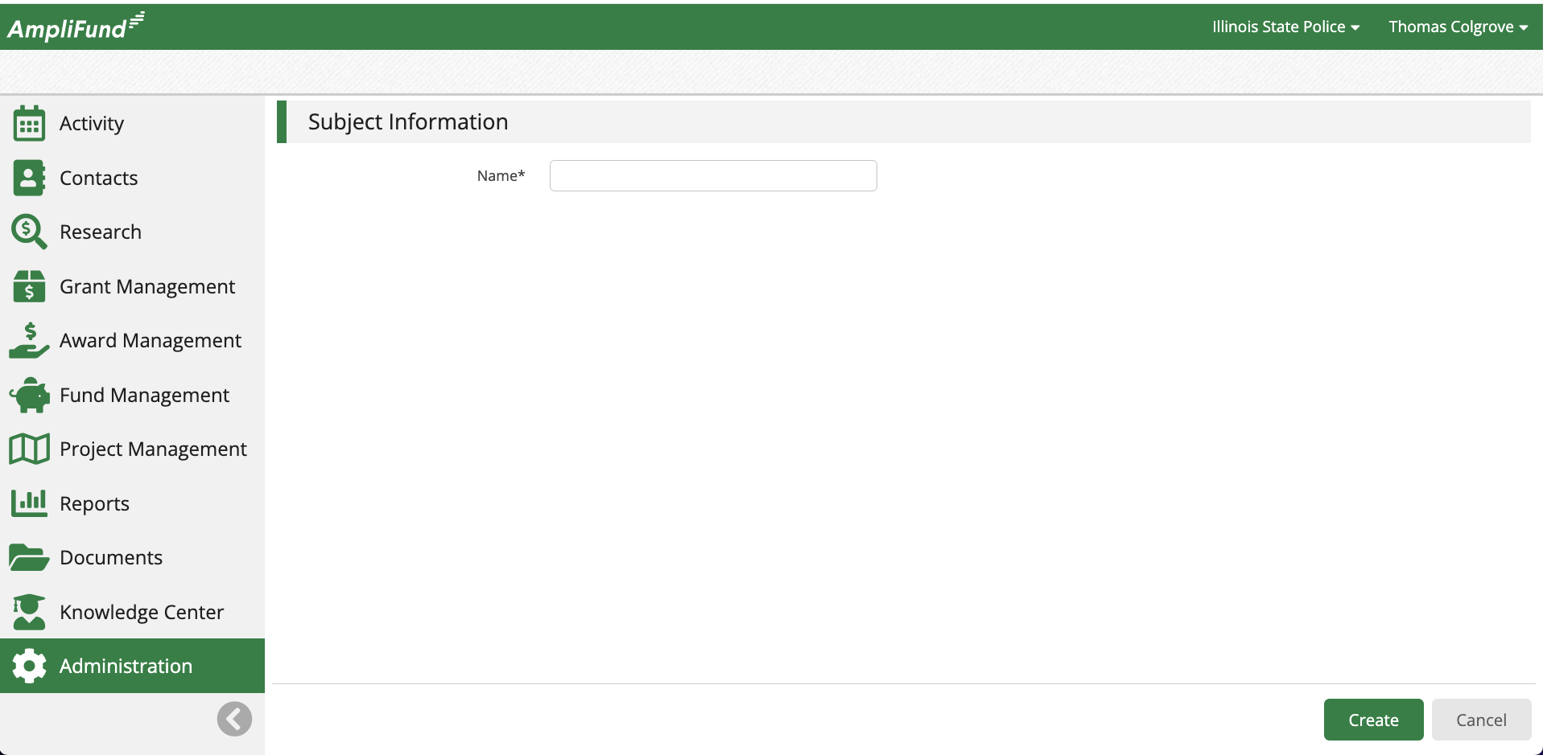

Users
Users can log into AmpliFund and create/update objects in the system based on their assigned role. All Illinois users must have an Illinois.gov email.
Complete the following steps to access, update, and create Users.
- Click on Administration > System Security > Users.
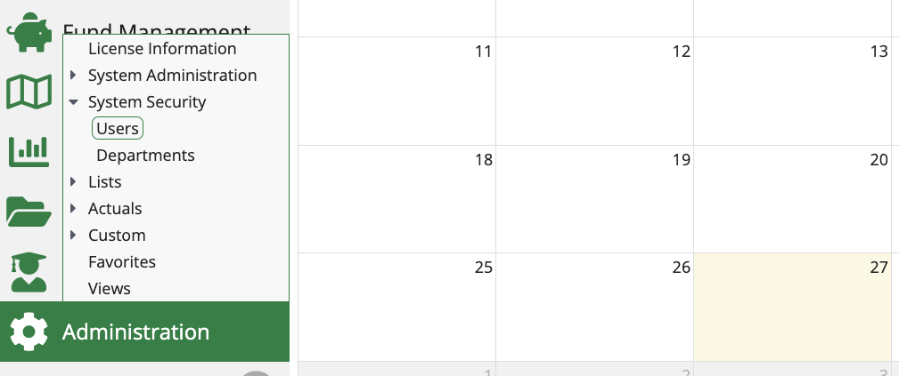
- Click the pencil icon to update.
- Click on the trashcan icon to delete.
- Click on the + icon on the top right of the screen to add a new User.
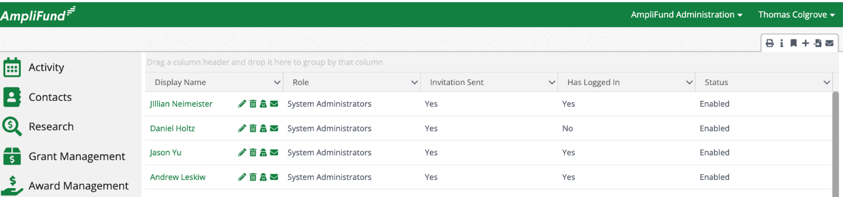
- Configure the User Information.
- Configure the Security Information.
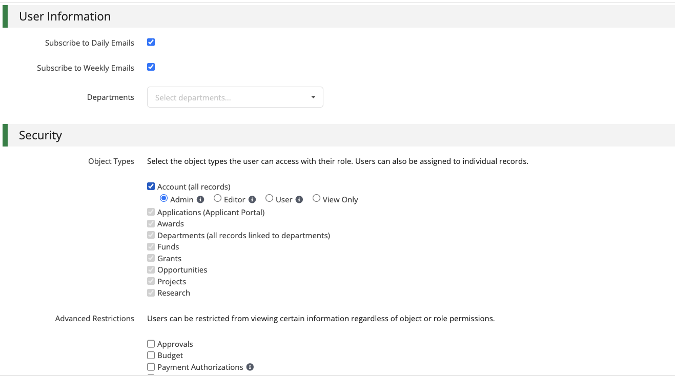
- Configure the Staff Information.
- Configure any other relevant information.
- Anything marked with an * is required.
- Click Create on the bottom right of the screen.
- All users must have an Illinois.gov email account.
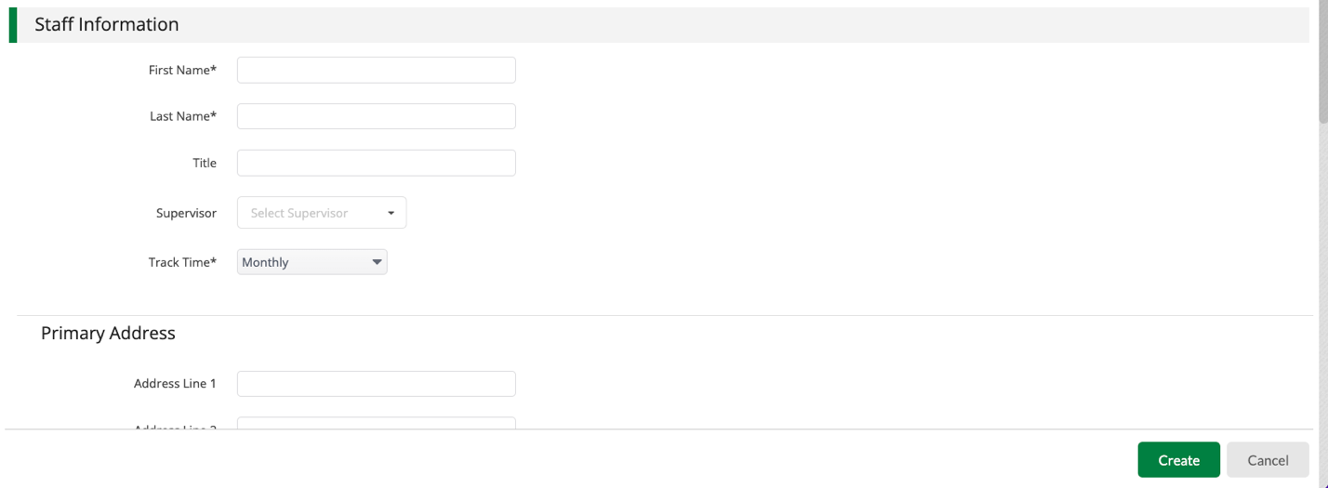
User Security Video and PDF - https://il-amplifund.zendesk.com/hc/en-us/articles/35577832633491-User-Security-Training-Grant-Maker-11-2024
User Security Access Article - https://il-amplifund.zendesk.com/hc/en-us/articles/35528915255827-User-Security-Access
User Security Access PDF - https://il-amplifund.zendesk.com/hc/en-us/article_attachments/35528944918803

Custom Budget Categories
Create custom budget categories and add them to the Standard Budget Template.
Complete the following steps to Access, Update, and add Custom Budget Categories. See the Fund Opportunities section for more detail.
- Click on Administration > Lists > Budget Categories.
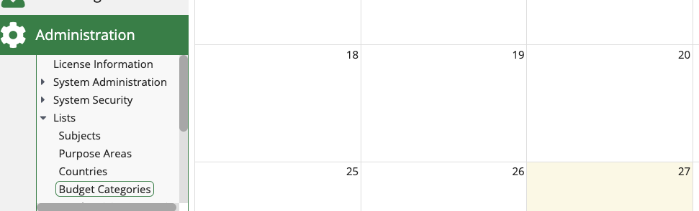
- Click on the pencil icon to edit.
- Click on the trashcan icon to delete.
- Click on the + icon on the top right of the screen.
- A new field will appear at the bottom of the list.
- Enter the Name (must be unique).
- Click the floppy disc icon next to the Name.
- Repeated this process for all new Budget Categories.
- Click Save Changes on the bottom right of the screen.
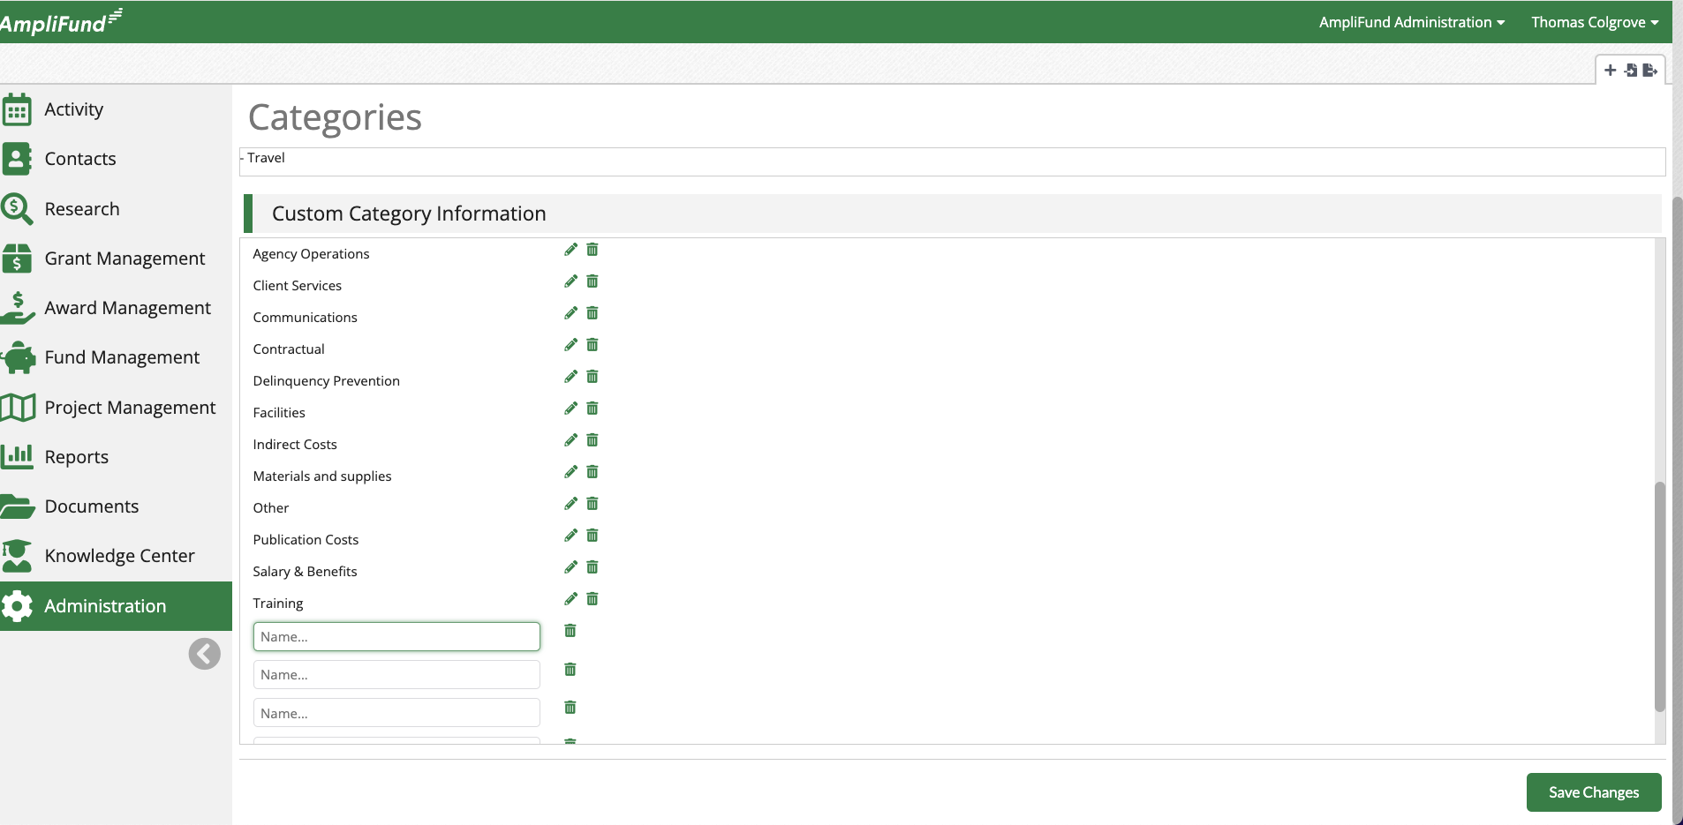

Purpose Areas
Purpose Areas offer an additional way to allocate and track grant budgets. Multiple Purpose Areas can be added to a single award, grant, or opportunity budget category, and Purpose Areas and be reported on globally.
Complete the following steps to access, update, and create Purpose Areas. See the Opportunity section for more detail.
- Click on Administration > Lists > Purpose Areas.
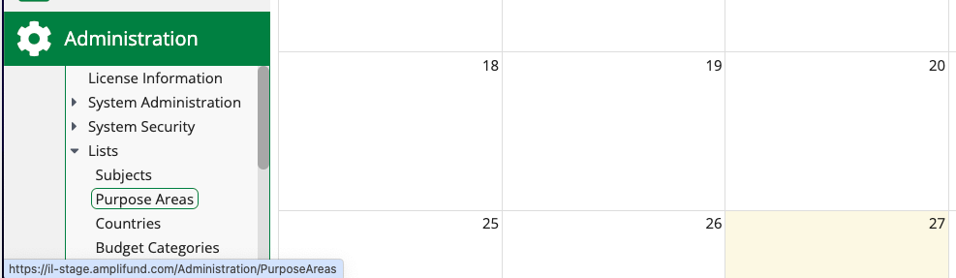
- Click the pencil icon to update.
- Click on the trashcan icon to delete.
- Click on the + icon to add a new Purpose Area.
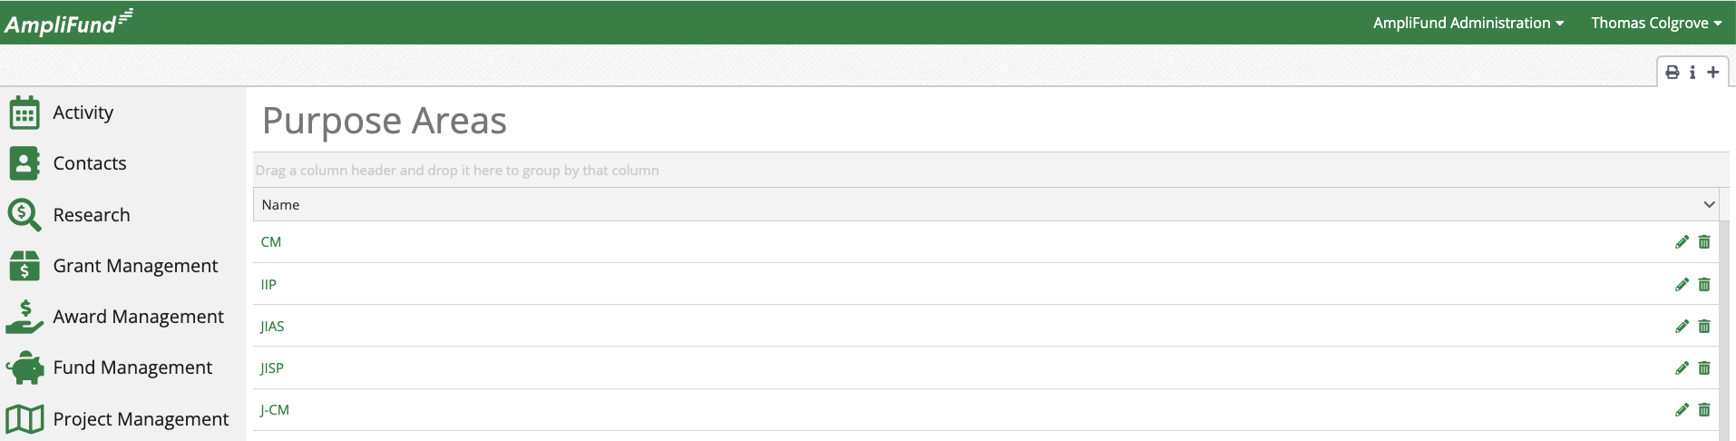
- Enter the Name.
- Click Create on the bottom right of the screen.
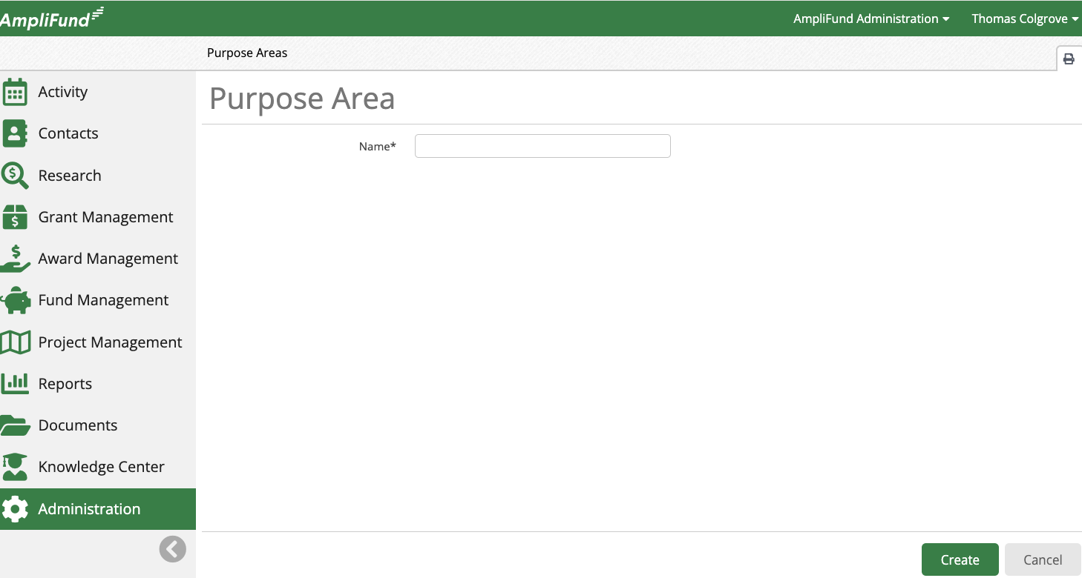

Award Workflow Considerations
Agencies typically use Workflow functionality to facilitate and track the Award, Uniform Grant Agreement, and ERP Contract creation business processes in AmpliFUnd.

Enroll Award into Workflow
Complete the following steps if using a Grant Workflow to enroll the Award into the appropriate Workflow and complete all the necessary Action Items.
- Click on Grant Management > Grants Awarded.
- Select the appropriate Award.
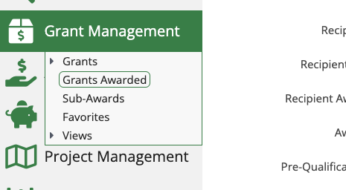
- Click on Grant Workflow > Award/UGA/Contract Workflow (The title of the Workflow Action item will vary by account).
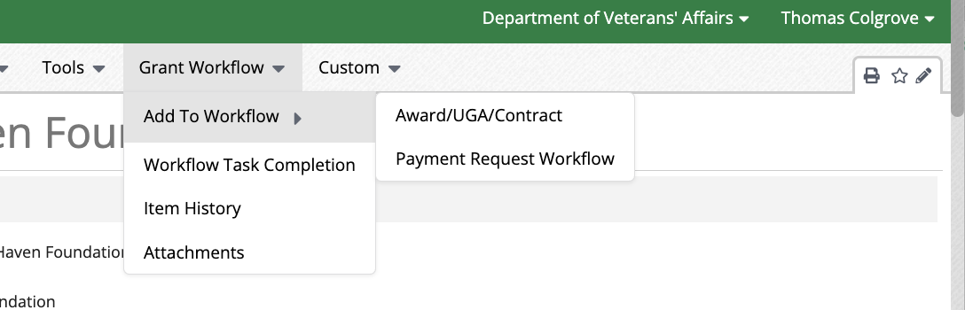
- Move the Award through the Workflow, complete all tasks, and remove from the Workflow after completion.

Access Workflows
Complete the following steps to access Workflows.
- Click on Administration > System Administration > Workflow.
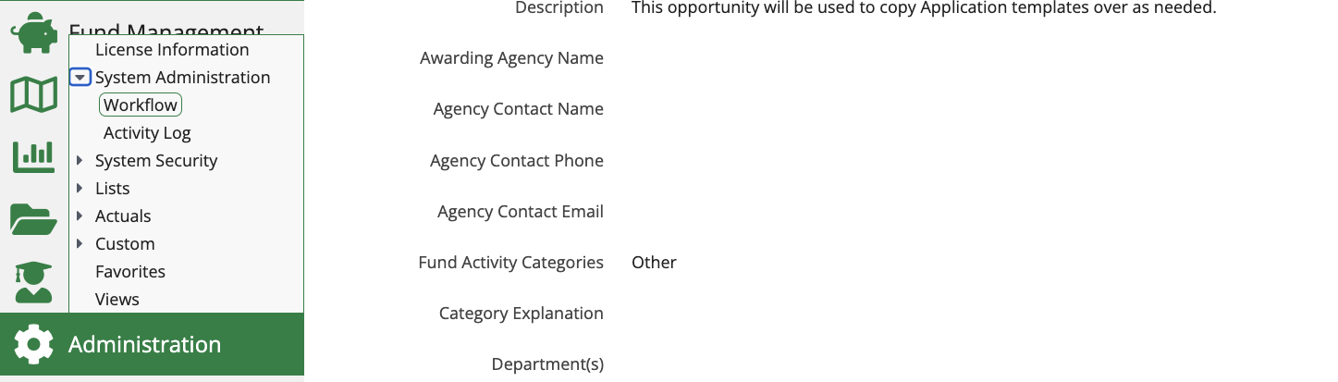
- Land on a list of all Workflows.
- Click the pencil icon to update.
- Click on the paper icon to copy.
- Click on the gear icon to edit Workflow Queues.
- Click on the trashcan icon to delete.
- Click on the Object Currently Enrolled for a list of all objects currently enrolled.
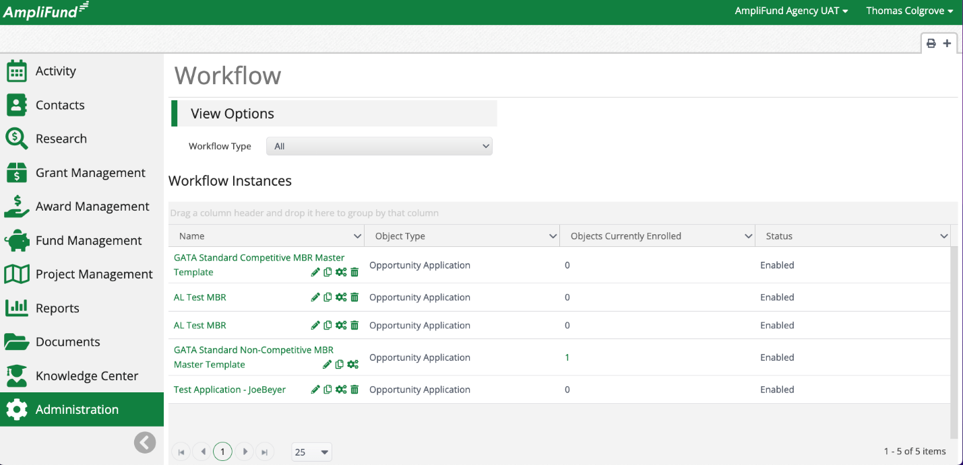

Create Workflows
- Click on the + icon on the top right of the screen.
- Select the Object Type.
  - Opportunity Application for Pre-Award Workflow.
  - Grant for Award and Post-Award Workflows.
- Enter Description as needed.
- Configure Action Alerts to alert a user of inaction withing the Workflow as needed.
  - Set Action Alerts to Yes.
  - Select the number of Days Since Last Action.
  - Select the Appropriate Users.
  - Click Add.
- Click save on the bottom right of the screen.
- Land on the Workflow Configuration page.
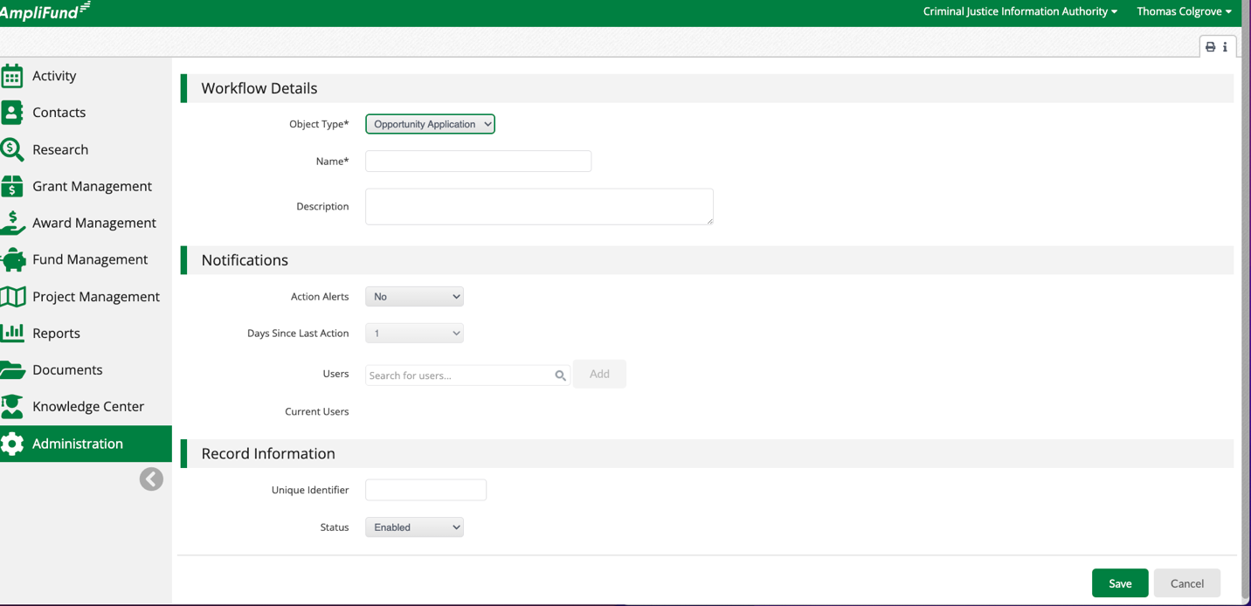

Configure Workflows Queues
Workflows are made up of Queues and Action Items. Queues are the phase of the process and Action Items are the steps within each process phase.
Complete the following steps to create and update Workflow Queues.
- Click + next to Add Workflow Queues.
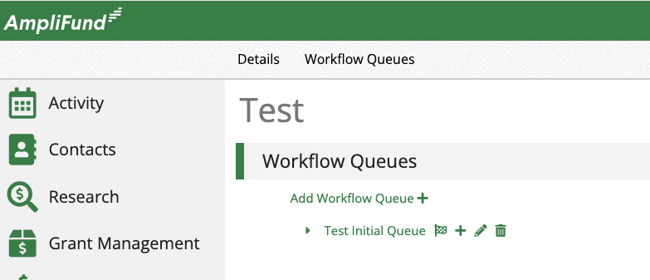
- Enter the Name.
- Enter the Description as needed.
- Select the Change Submission Status. Below are the most common Change Submission Statuses. Each of these statuses triggers a system-generated email notification to the Applicant. In most cases, if none of the statuses listed below are used, the Change Submission Status will default to No Change.
  - Approved – Application is approved and ready to create the Award.
  - Rejected – Application is rejected and automatically removed from the Workflow.
  - Reopened – Application is reopened and the Applicant can make the required updates. Review Application Review and Scoring for more information.
- Add User and click Add.
  - Users assigned at the Queue level will have access to all Action Items within the Queue.
- Click Save on the bottom right of the screen.
- Repeat this process for all Workflow Queues.
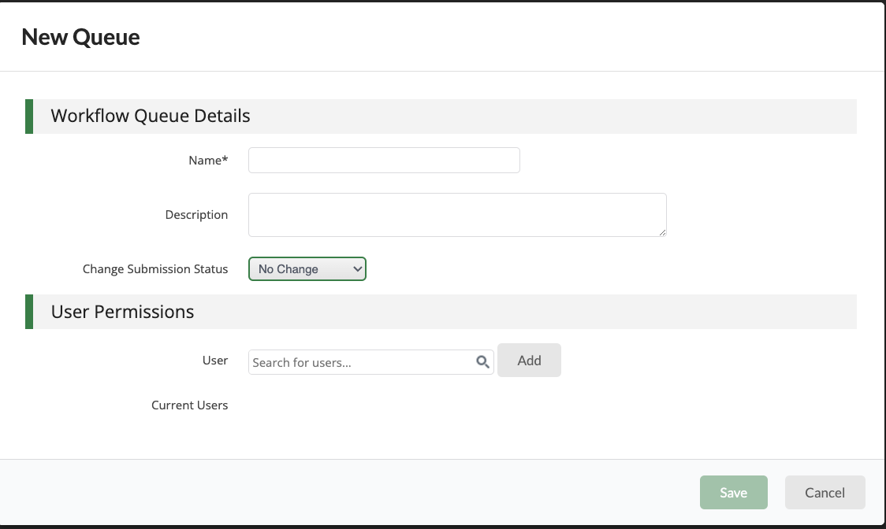
- Click the pencil icon to edit.
- Click the trashcan icon to delete.
  - Cannot delete a Queue if Applications are enrolled in that Queue.

Configure Workflow Action Items
Workflows are made up of Queues and Action Items. Queues are the phase of the process and Action Items are the steps within each process phase.
Complete the following steps to create and update Workflow Action Items.
- Click on the + next to the appropriate Workflow Queue.
- Enter the Name.
- Enter the Description as needed.
- Select the Action Type.
- Add User and Click Add.
  - Users assigned at the Action Item level only have access to that Action Item.
- Click Save.
- Repeat this process for all Action Items.
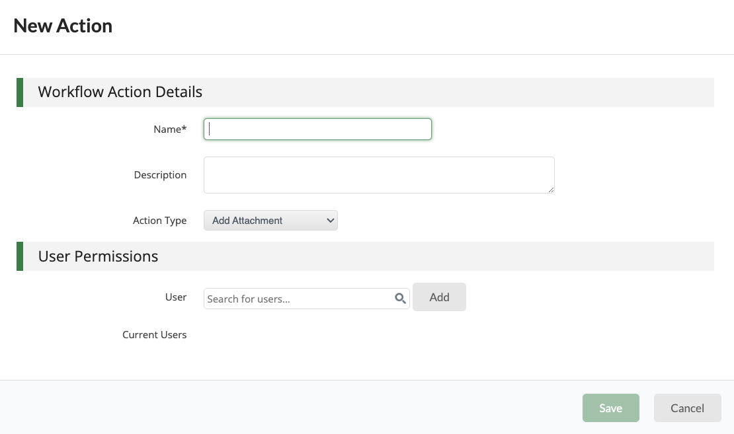
- Click the pencil icon to edit.
- Click on the arrows to reorder.
- Click the trashcan icon to delete.
  - Cannot delete an Action Item if Applications are enrolled in that Queue.
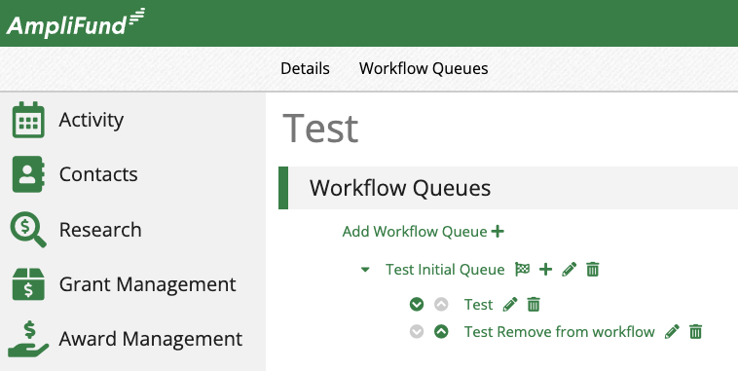

Workflow Considerations
System generated emails are sent when the Award Status changes to Approved, Rejected, or Reopened. The System Generated emails cannot currently be updated. Follow the Release Notes on the customer support site to stay up to date on new product releases. Consider sending all necessary communications to the Applicants outside of the system before moving Applications to the Approved Queue and creating Awards.
Follow Release Notes here - https://il-amplifund.zendesk.com/hc/en-us/categories/360001754633

Additional Workflow Resources
Workflow Guide - https://il-amplifund.zendesk.com/hc/en-us/articles/360022583233-Workflow-Guide
Working with Workflow – https://il-amplifund.zendesk.com/hc/en-us/sections/1500000901702-Working-with-Workflow
Workflow Core Series Session - https://il-amplifund.zendesk.com/hc/en-us/articles/30901477742739-Grant-Maker-Pre-Award-Application-Review-Workflow-Configuration-Testing

Award Creation

Award Pre-Requisites
When using Pre-Award functionality to collect applications through an Opportunity Awards must be created through Application Review Workflow. The Application must be enrolled in the appropriate Workflow Queue with a Change Submission Status of Approved. When the Application enters the Approved Workflow Queue an automated email is sent to the to the Applicant informing them the Application is approved. After creating the Award, the Application automatically removes from the Workflow.

Create Award Through Workflow
- Click on Award Management > Fund Opportunities.
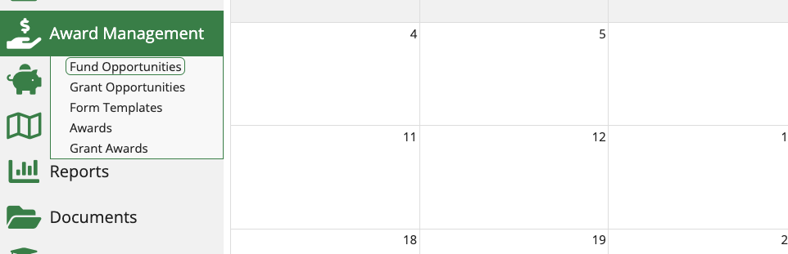
- Select the appropriate Opportunity.
- Click on the Applications tab across the top of the screen.
- Select the appropriate Application
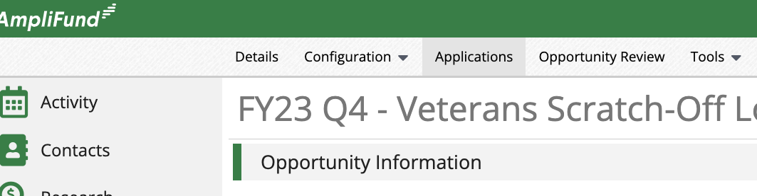
- Click on Workflow > Available Actions > Create Award in AmpliFund (The title of the Workflow Action item will vary by account).
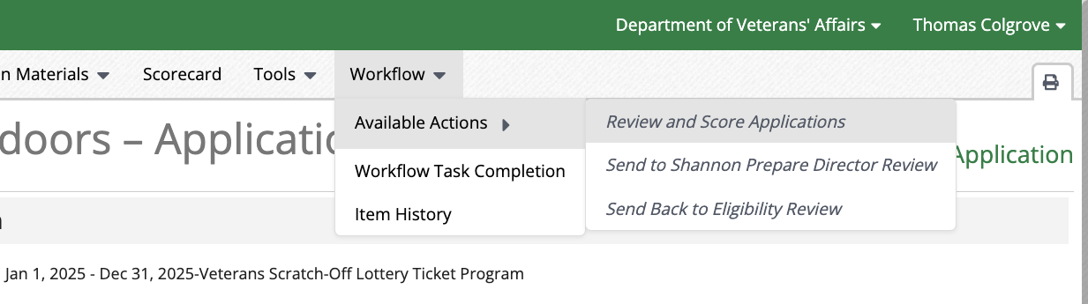
  - Select the Responsible Person.
  - Enter the Award Identification Number.
  - Enter the Award Name.
  - Enter the Awarded Date.
  - Enter the Start Date.
  - Enter the End Date.
  - Enter the Awarded Amount.
  - Click Create on the bottom right of the screen.
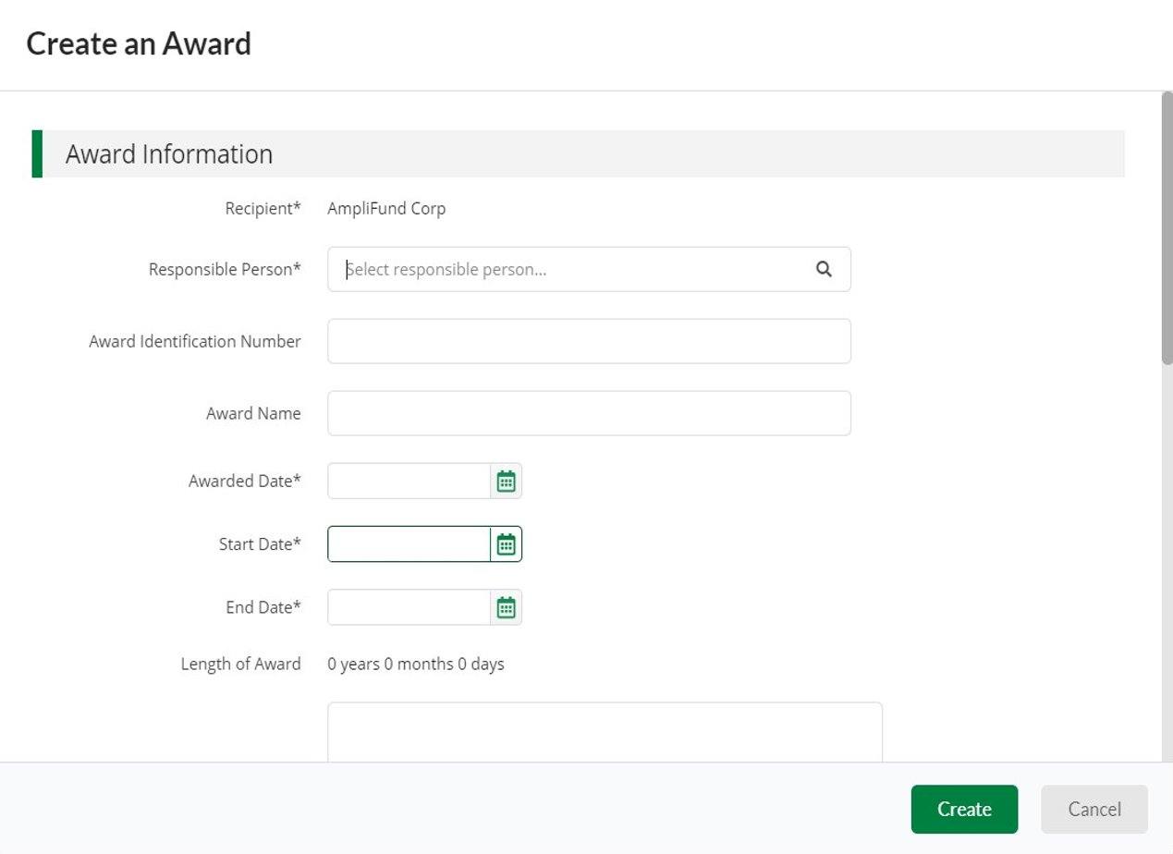
- The Application is automatically removed from the Application Review Workflow.
- Land on the new Award Details page.
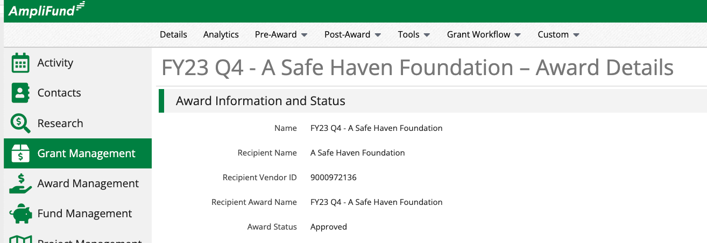

Award Details

General Award Information
Several considerations must be made to configure Awards effectively. Including but not limited to communication and change management, Master Data, Award Details, Award Settings, Reporting Frequency, Budget, and Performance Plan. The best practice is to fully understand all programmatic requirements and data points before configuring the Awards. The Grantees report and manage their Grant based on how the Award is configured.
Access Award Details
Understanding how to access and update Awards is important moving forward as all updates to the Award start from the Award Details page.
Complete the following steps to access Awards.
- Click on Grant Management > Grants Awarded.
- Select on appropriate Award.
- Land on the Award Details Page.

Configure Award Details
Award Details include Award information including but not limited to the Award Name, Recipient, Person Responsible, Grant Manager, Awarded Amount, Award Dates and more. The Award Details provide access to Analytics, Pre-Award, Post-Award, Tools, Grant Workflow, and Custom configuration tabs across the top of the screen that enable access to more data and advanced management tools.
Complete the following steps to update the Award Details.
- Click on the pencil edit icon on the top right of the screen.
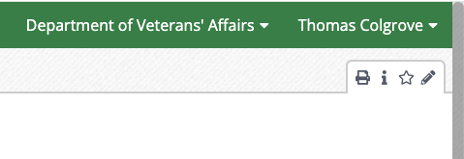
- Review all the details entered when creating the Award.
- Select the Person Responsible.
- Select the Grant Manger – This person will receive system notifications about the Award.
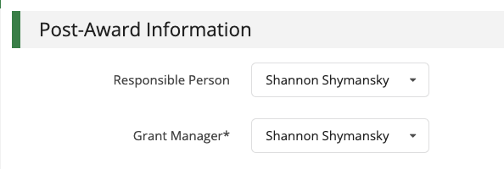
- Update other Award Details as needed.
- Click Save on the bottom right of the screen.
- Activate the Award when ready for Grantees to access.
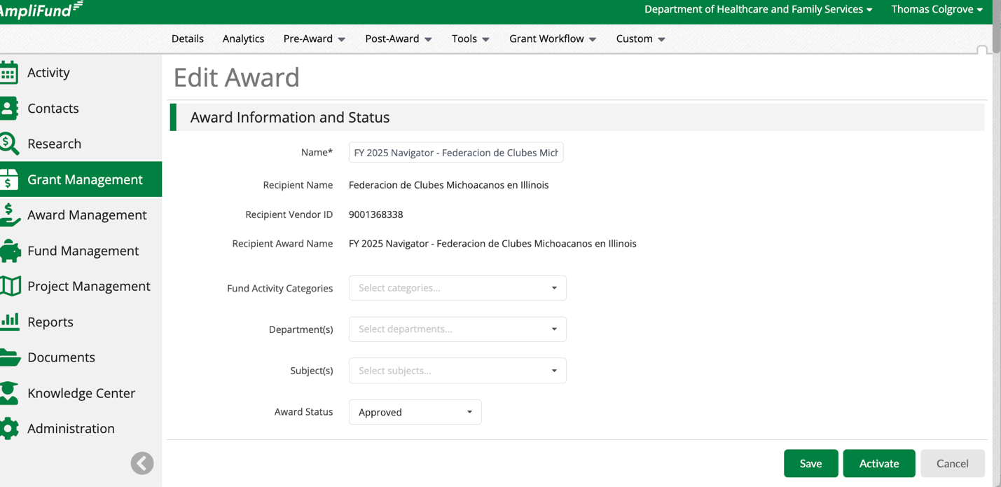

Uniform Grant Agreement

General Uniform Grant Agreement Information
Uniform Grant Agreement sections are comprised of two Custom Form Extensions. One can be added to the Opportunity (Program Level) and the other can be added to the Award (Award Level) record.
All information added entered at the Award level will populate only on that specific Uniform Grant Agreement. For example, if you add a project description in the Exhibit A: Project Description (Award Level) it will only populate on that Uniform Grant Agreement Report. Whereas, if you add a project description in the Exhibit A: Project Description (Program Level) it will populate on all Uniform Grant Agreement.
Contact your AmpliFund implementation team with question about the Uniform Grant Agreement.
Complete the following steps to access and review Custom Form Extensions.
- Click on Administration > Custom > Form Extension Library.
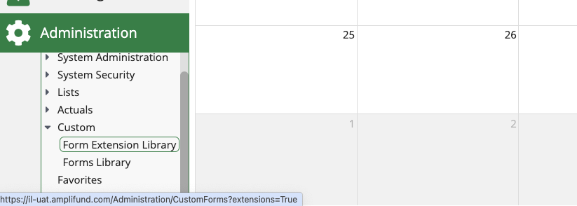
- Land on a list of all Custom Form Extensions in your account.
- Review the grid for the following data:
  - Object – Determines what record the Custom Form Extension can be or is connected to.
  - Global – If yes, the Custom Form Extension will populate on all records in the Object column. If no, Funders must manually add the Custom Form Extension to the record.
  - Recipient – If yes, only the Grantee can complete and submit the form to Funders. If no, Funders can complete the form.
  - Published – Custom Form Extension must be published to populate on records in the Object column and to run custom reports.
  - Description – If a description was added when creating the Custom Form Extension it will populate here.
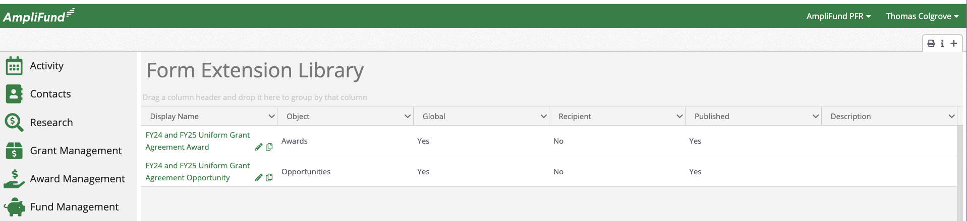
Complete the following steps to set a Custom Form Extension to Global ensuring it populates on all records.
- Click on Administration > Custom > Form Extension Library.
- Click on the pencil edit icon next to the appropriate Custom Form Extension.
- This document is focused on the standard FY24 and FY25 Uniform Grant Agreement Opportunity (Award):
  - F24 and FY25 Uniform Grant Agreement Award
- Check the Enable Form Extension on All Records for Object(s) checkbox.
- Click Save on the bottom right of the screen.
- Click Save/Publish on the bottom right of the screen.
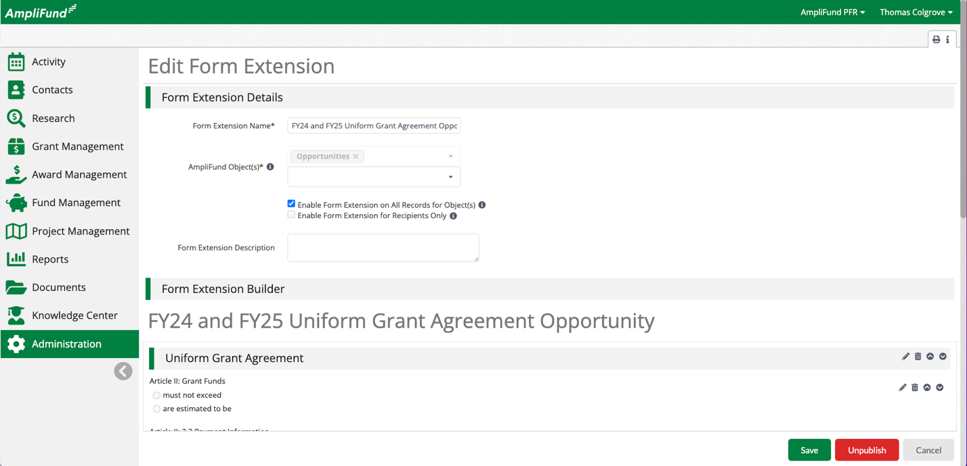
Complete the following steps to add a Custom Form that is not Global to a specific Opportunity.
- Click on Award Management > Fund Opportunities.
- Click on the title of the appropriate Opportunity.
- Click on Custom > Form Configuration.
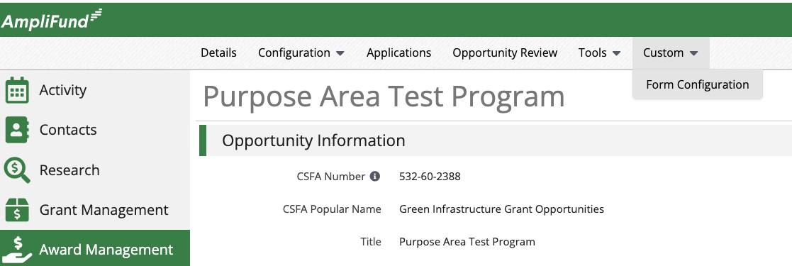
- Check the FY24 and FY25 Uniform Grant Agreement Opportunity checkbox.
- Click Save on the bottom right of the screen.
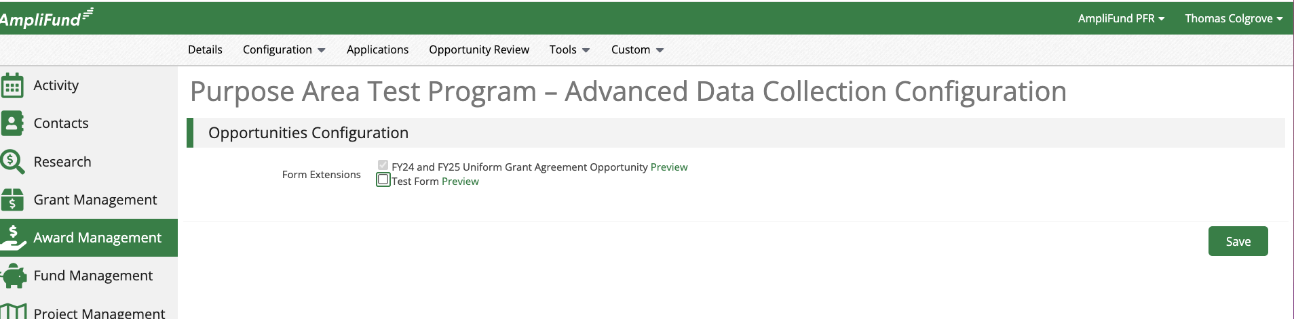

Uniform Grant Agreement Custom Form Considerations
- The State periodically reviews and updates the Uniform Grant Agreement.
- Agency use and configuration of the Uniform Grant Agreement Custom Form Extension vary based on programmatic requirements.
- There may be several versions of the Uniform Grant Agreement Custom Form Extension in your account based on programmatic requirements.
- This document covers the standard configuration. Consider contacting your AmpliFund implementation team with questions or about customization requirements.
- AmpliFund will support Agencies with updating the Standard Uniform Grant Agreement including the standard Custom Report and standard Template. Contact your AmpliFund implementation team with questions about the Uniform Grant Agreement process.

Award Settings
Settings include the Budget Reporting Frequency and Due Dates, Performance Reporting Frequency and Due Dates, Payment Request settings, and Amendment Type settings.

Configure Grant Settings
Complete the following steps to configure the Grant Settings.
- Click on Grant Management > Grants Awarded.
- Select the appropriate Award.
- Click on Post-Award > Settings > Grant Settings.
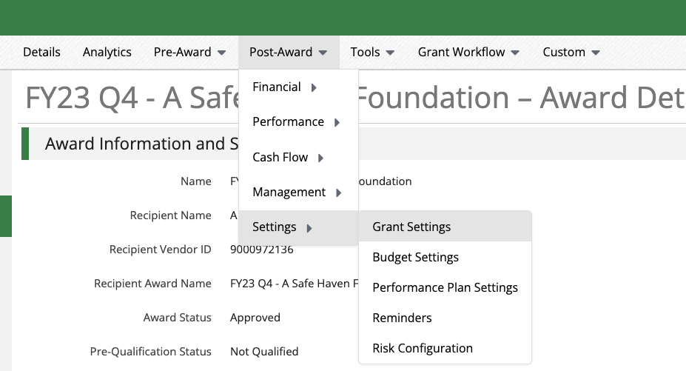
- Click on the pencil edit icon on the top right of the screen.
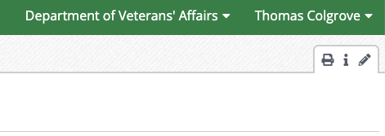
- Configure the Budget Reporting Period frequency.
  - Annual, Semi-Annually, Quarterly, Monthly.
  - Configure the Due Date For Budget Items.
- Configure the Performance Reporting Period frequency.
  - Annual, Semi-Annually, Quarterly, Monthly.
  - Configure the Due Date For Performance Items.
- Configure the Add Expenses to Payment Request settings.
  - How Grantees can add Expenses to the Payment Request. This can be through the Reporting Period, Date Ranges, or both.
- Configure the Allowable Amendment Types settings.
  - What Amendment Types Grantees can submit.
- Click Save on the bottom right of the screen.
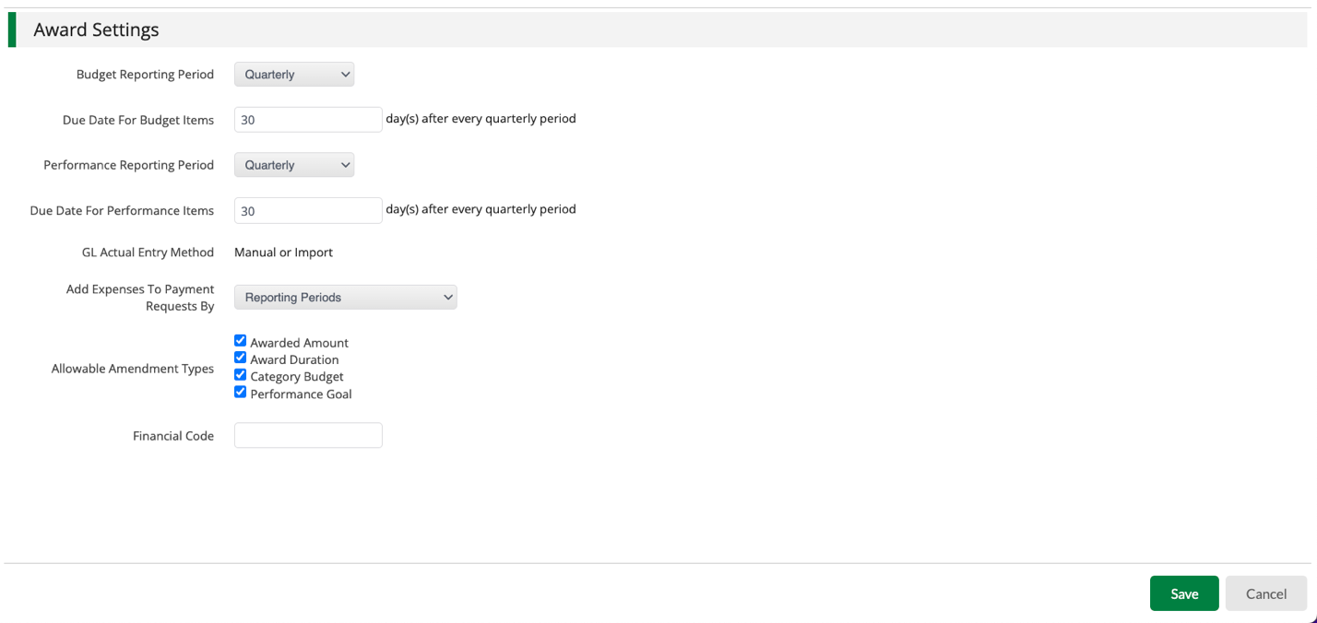

Configure Performance Plan Settings
Performance Plan settings control Grantee access to the Performance Plan and Available Goal Types.
Complete the following steps to configure the Performance Plan Settings.
- Click on Post-Award > Settings > Performance Plan Settings.
- The best practice is to configure the Recipient Settings as follows.
  - Set the Performance Plan Creation Permissions to Recipient can view, Funder can edit.
  - Set Achievement Creation Permissions to Recipient can edit, Funder can view.
- Click Save on the bottom right of the screen
- Performance Plan Consideration.
  - Disregard the Available Goal Types section when copying the Pre-Award Performance Plan to the Post-Award. All settings copy from the Pre-Award to the Post-Award. See the Configure Performance Plan section for more detail.
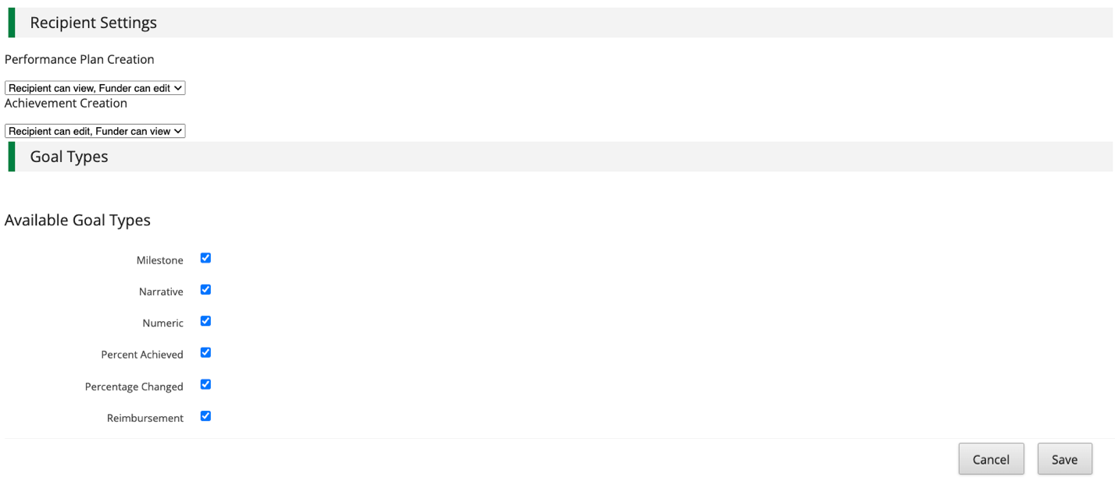

Configure Budget Settings
Budget Settings control Grantee access to the Budget, Matching Settings, Reconciliation Method, and Allowable Budget Categories.
Complete the following steps to configure the Budget Settings.
- Click on Post-Award > Settings > Budget Settings.
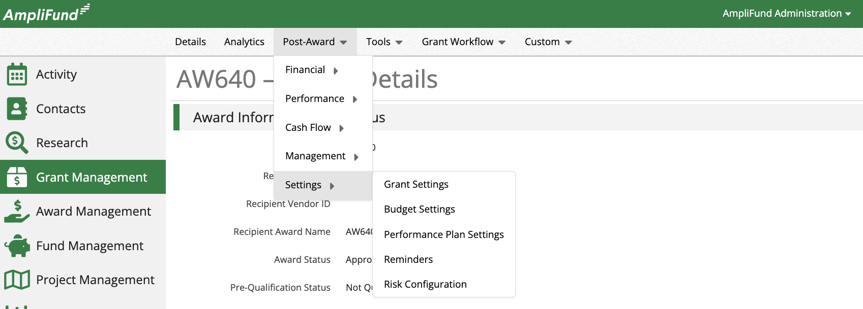
- Click on the pencil edit icon on the top right of the screen.
- The best practice is to configure the Recipient Settings as follows.
  - Set the Budget Creation Permissions to Recipient can view, Funder can edit.
  - Set Expense Creation Permissions to Recipient can edit, Funder can view.
- Matching settings considerations.
  - Funders can enable, disable, or require Grantees to add Match contributions when entering Expenses.
  - Consider programmatic requirements. For example, if your program does not track Match contributions, you might disable the Match requirement.
  - Funders can set the Default Match to a Dollar or Percentage.
- Reconciliation Method Considerations.
  - Funders typically use the Reimbursement method.
  - Funders can use the Advance Payment or Working Capital options.
- Complete the following steps when configuring the Budget Categories manually.
  - Scroll down to the Budget Categories section.
  - Select the appropriate Category from the dropdown.
  - Click Add.
  - Repeat for all necessary Budget Categories.
- Click Save on the bottom right of the screen.
- Budget Category Consideration.
  - Disregard the Categories section when copying the Pre-Award Budget to the Post-Award. All settings copy from the Pre-Award to the Post-Award. See the Configure Budget Manually section for more detail.
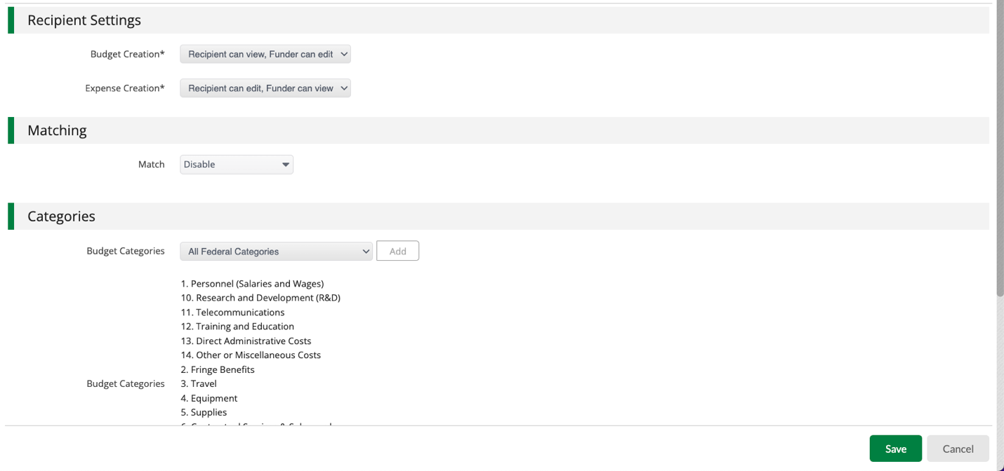

Post-Award Performance Plan

Copy Pre-Award Performance Plan to Post-Award
Copy the approved Pre-Award Performance Plan to the Post-Award in a couple of clicks! Pre-Award Performance Plan information must be collected from Applicants during the Application process to use this functionality.
Complete the following steps to copy the Pre-Award Performance Pan to the Post-Award.
- Click on Pre-Award > Submission Performance Plan.
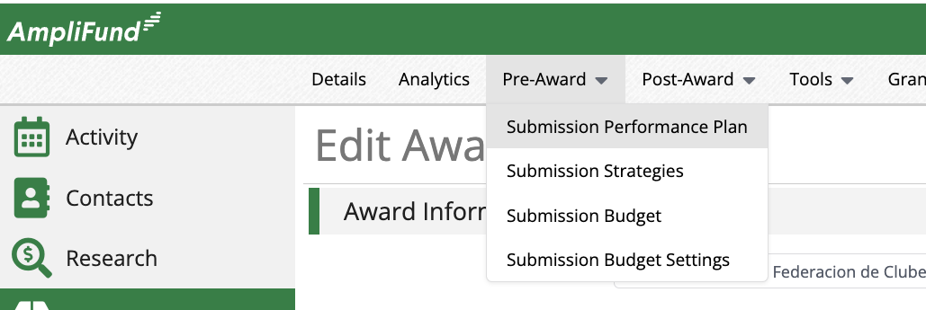
- Click on the copy icon on the top right of the screen.
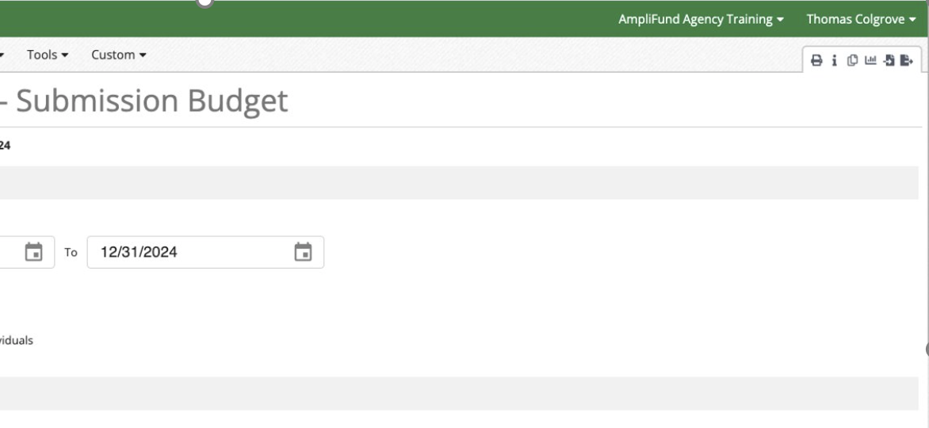
- Click Confirm on the popup window.
- Land on the Post-Award Performance Plan.

Access Post-Award Performance Plan
The Performance Plan must be copied from the Pre-Award or configured manually in the Award Phase before accessing the Post-Award Performance Plan.
Complete the following steps to add a Strategy to group Performance Plan Goals.
- Click on Post-Award > Performance > Performance Strategies.
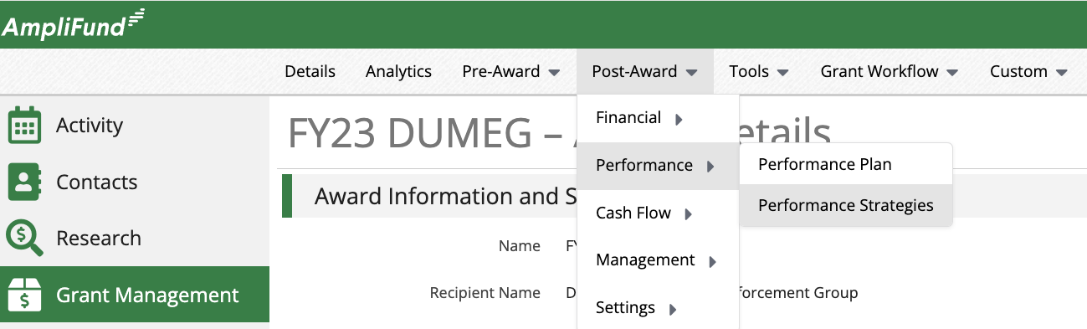
- Click on the + icon on the top right of the screen.
- Enter Name.
- Enter Description.
- Click save on the bottom right of the screen.
- Repeat for all Performance Strategies.
  - There is no right or wrong way to use this functionality and Performance Strategies are not required. The Functionality enables grouping similar Performance Plan goals.
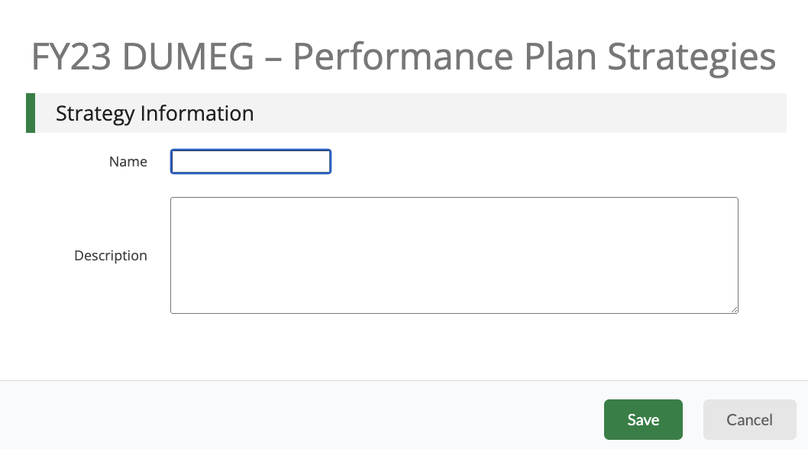
Complete the following steps to access the Post-Award Performance Plan.
- Click on Post-Award > Performance > Performance Plan.
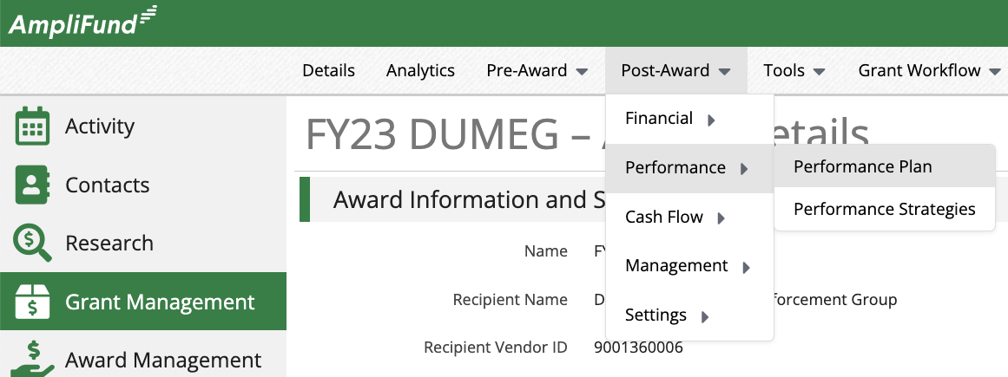
- Click the pencil edit icon next to update.
- Click on the paper icon to copy.
- Click on the trashcan icon to delete.
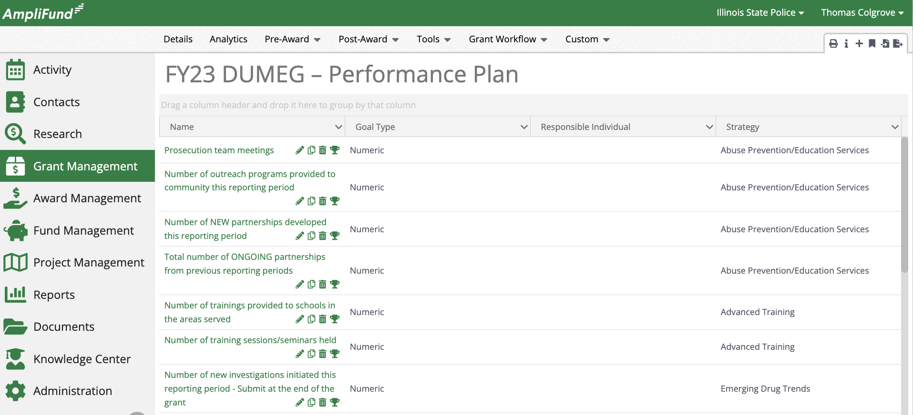

Create Performance Plan Goal
Consider Goal Types when configuring the Post-Award Performance Plan. Each Goal Type requires different information. For example, a Milestone Goal Type requires a due date. A Narrative Goal Type requires a question to be answered. A Numeric Goal Type requires a number to be achieved.
Learn more about Goal Types here - https://il-amplifund.zendesk.com/hc/en-us/articles/360022587573-Performance-Goal-Types
Complete the following steps to create and update a Performance Plan Goal.
- Click on Post-Award > Performance > Performance Plan.
- Click on the + icon on the top right of the screen.
- Select Strategy (optional).
- Select Goal Type.
- Enter Name.
- Enter Description (optional).
- Select Responsible Type.
  - If Individual select Responsible Individual.
- Configure Goal Type required fields.
- Click Create on the bottom right of the screen.
- Review Allocations as needed.
- Add Attachments as needed.
- Repeat for all Performance Plan Goals.
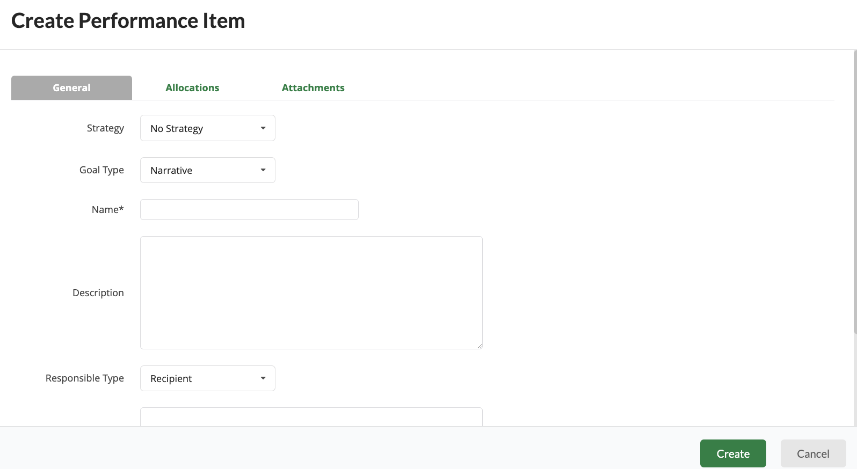

Post-Award Budget

Copy Pre-Award Budget to Post-Award
Copy the approved Pre-Award Budget to the Post-Award in a couple of clicks! Pre-Award Budget information must be collected from Applicants during the Application process to use this functionality. All Pre-Award Budget Category settings will transfer from the Pre-Award Budget to the Post-Award. Other sections of the Budget Settings such as the Matching and Reconciliation Method must still be configured.
Complete the following steps to copy the Pre-Award Budget to the Post-Award.
- Click on Pre-Award > Submission Budget.
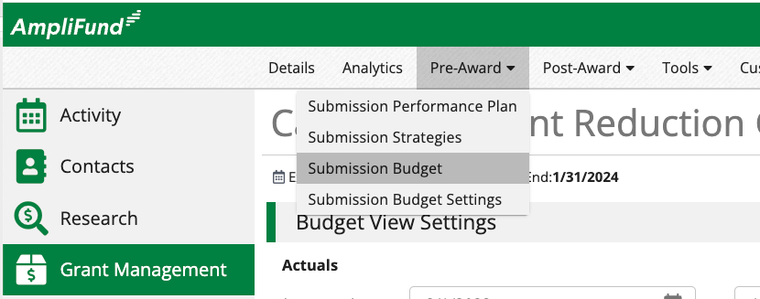
- Click on the copy icon on the top right of the screen.
- Click Confirm on the popup window.
- Land on the Post-Award Budget.

Access Post-Award Budget
The Budget Settings must be copied from the Pre-Award or configured manually in the Award Phase before accessing or updating the Post-Award Budget. Update the Post-Award Budget as needed throughout the Award.
Complete the following steps access the Post-Award Budget.
- Click on Grant Management > Grants Awarded.
- Select the appropriate Award.
- Click on Post-Award > Financial > Budget.
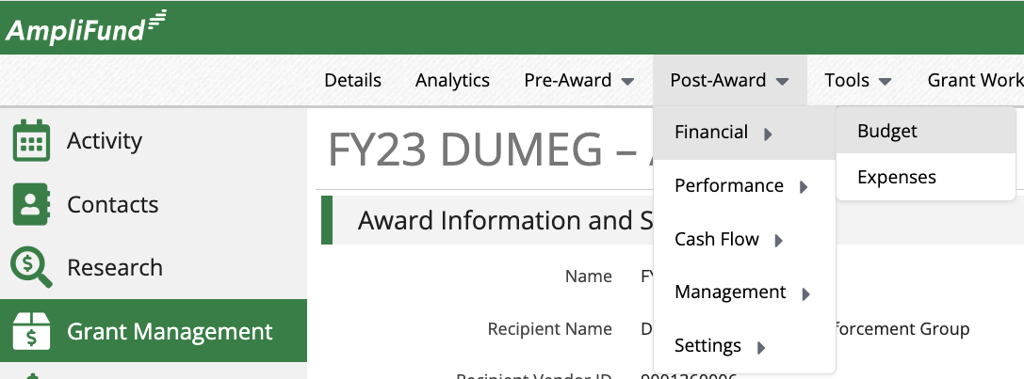
- Configure the Budget View Settings.
  - Configure Show Actuals From date ranges (default from Award Start Date to Award End Date).
  - Check the Line Items Checkbox.
  - Check other Options checkboxes as needed.
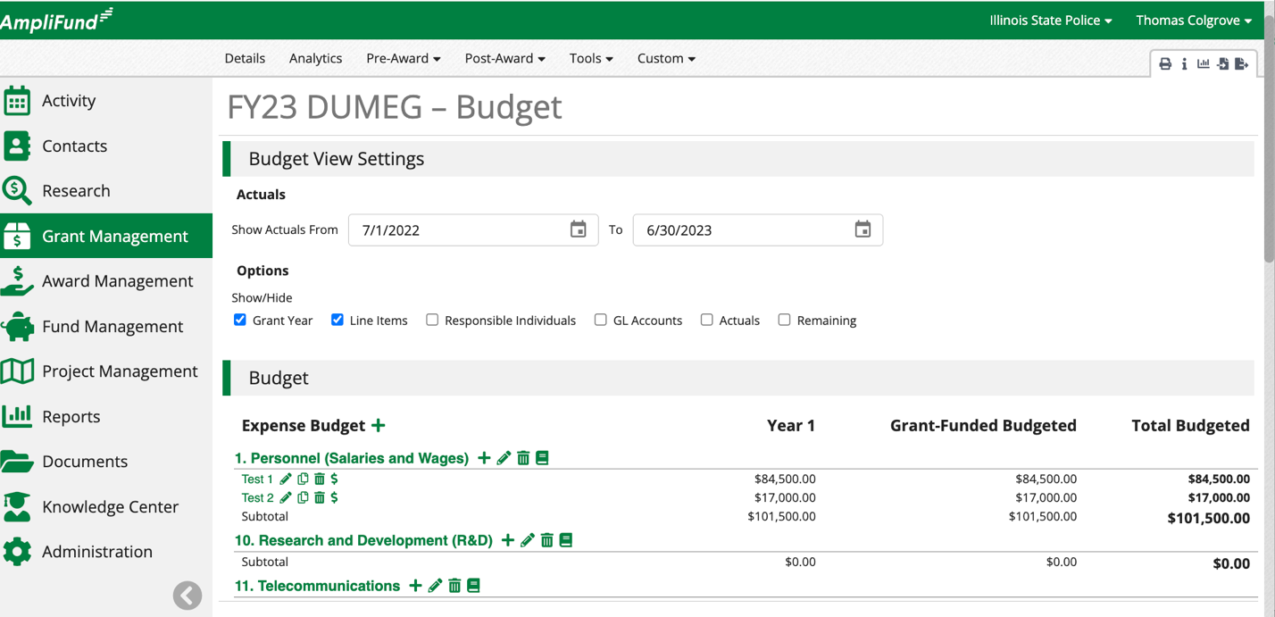

Create and Update Budget Categories
Consider the Budgeted Amount, Allowable Item Type (how grantees can enter Expenses), Match, Expense Caps, Spending Alerts, and Purpose Areas when configuring Budget Categories manually.
Complete the following to create and update Budget Categories manually.
- Click on the + icon next to Expense Budget.
- Click the pencil edit icon next to update.
- Click on the paper icon to copy.
- Click on the trashcan icon to delete.
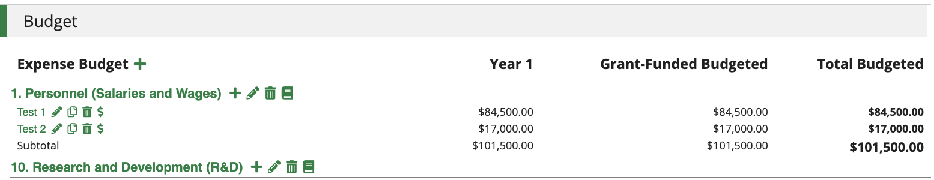
- Select Category.
- Enter Budget Amount.
- Select Allowable Item Type (how grantees can enter Expenses).
  - Non-Personnel – The simplest form of Expense entry and can be used for Personnel Expense.
  - Personnel – Bets to use when tracking Compensation information at the Staff level.
  - Direct Cost Calculation – Allows different Expense entry calculations such as Quantity x Rate.
- Configure Match settings.
  - Match Settings populate from the Budget Settings and can also be updated per Award.
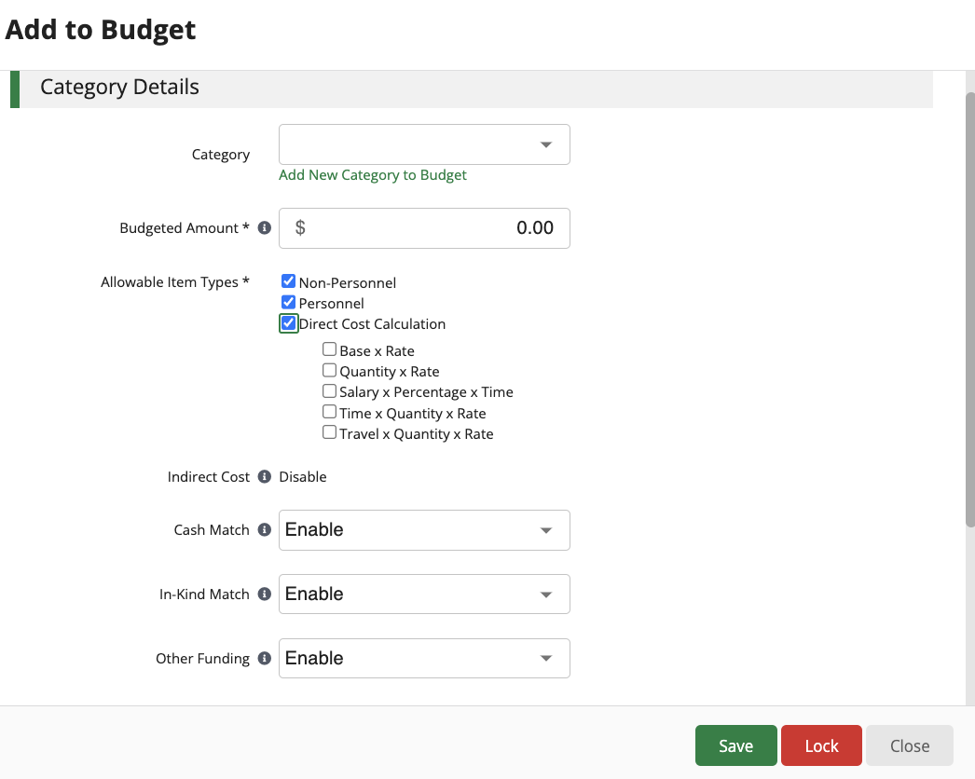
- Optional settings.
  - Add Expense Cap – No one Expense can exceed this amount.
  - Add Spending Alerts – Receive automated system notifications for monthly and total spending alerts.
  - Add Purpose Areas – Funders can add Purpose Areas to add additional layers of financial reporting. Line Items inherit Purpose Areas from the Category. Grantees are required to track against Purpose Areas when entering Expenses.
- Click Save on the bottom right of the screen.
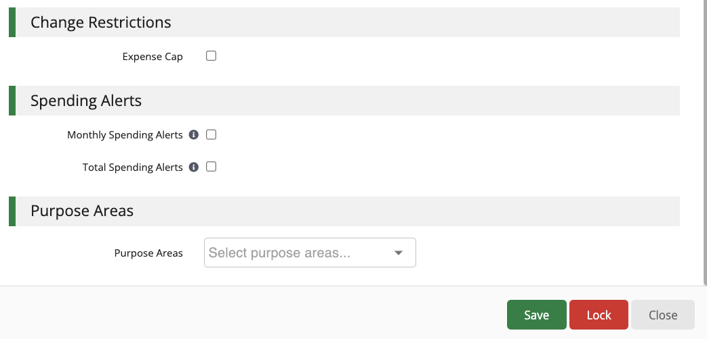

Create and Update Budget Line Items
Consider the Budgeted Amount, Match, Expense Caps, Spending Alerts, Purpose Areas, and Attachments when configuring Budget Line Items.
Complete the following to create and update Budget Line Items.
- Click on the + icon next to the Category.
- Select Item Type (Controls how Line Items calculate).
- Select Category.
- Enter Name.
- Enter Direct Cost.
- Configure Exclude From Match setting.
- Select Responsible Type.
  - If Individual select Person Responsible.
- Add Description (Optional).
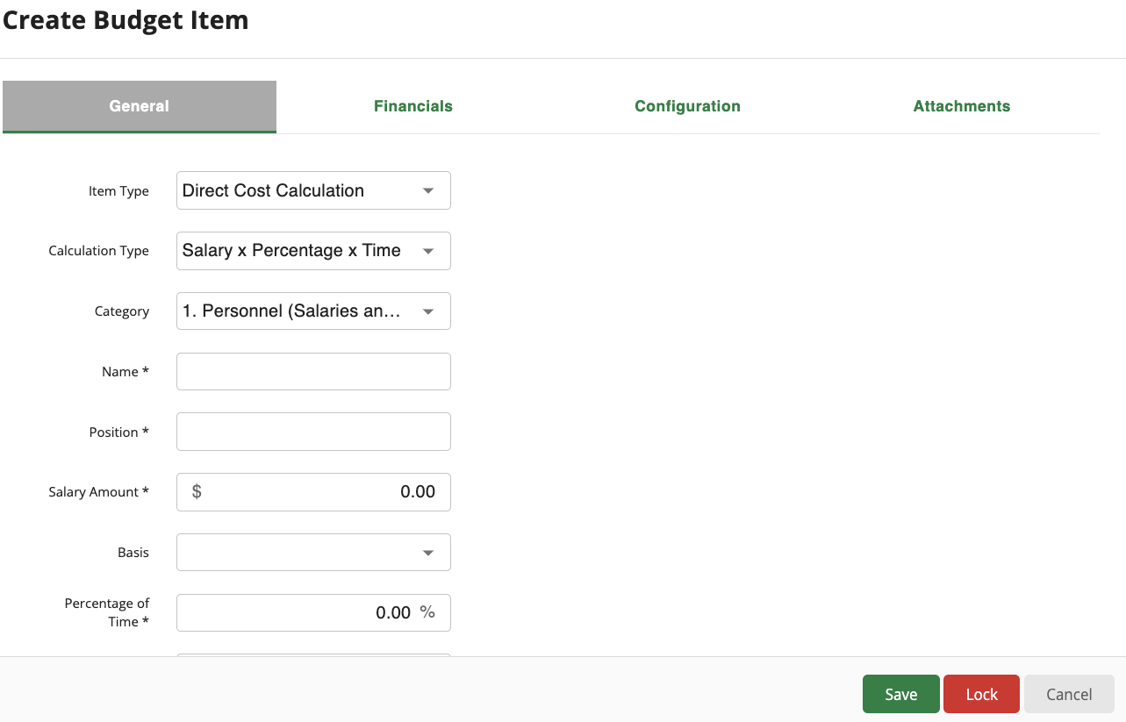
- Configure Match settings from the Financials tab across the top of the screen.
  - Match Settings populate from the Budget Settings and can also be updated per Award.
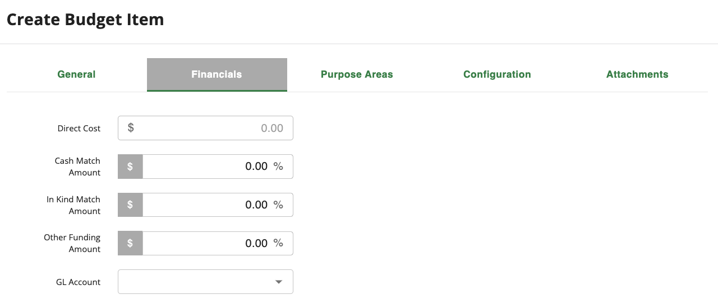
- Optional settings.
  - Add Purpose Area financial data from the Purpose Areas tab across the top of the screen. All the Direct Cost must be accounted for in all appropriate Purpose Areas for the Line Item including Grant Funded and Match Funding. Funds can be added to more than one Purpose Area and Match Funding source to account for the total Direct Cost.
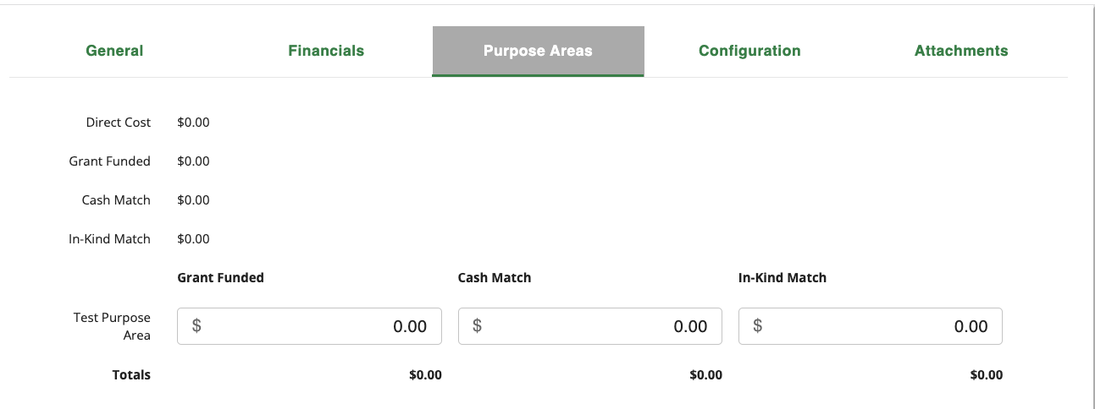
  - Add Expense Caps and Spending Alerts from the Configuration tab across the top of the screen.
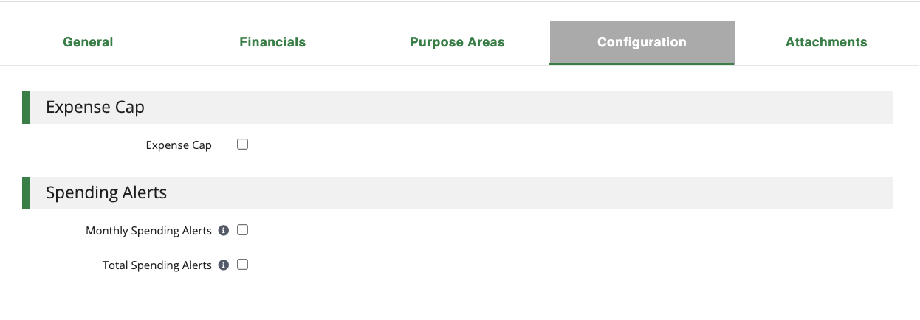
  - Add Attachments that are accessible at the Line Item Level from the Attachments tab across the top of the screen.
  - Click Save on the bottom right of the screen.
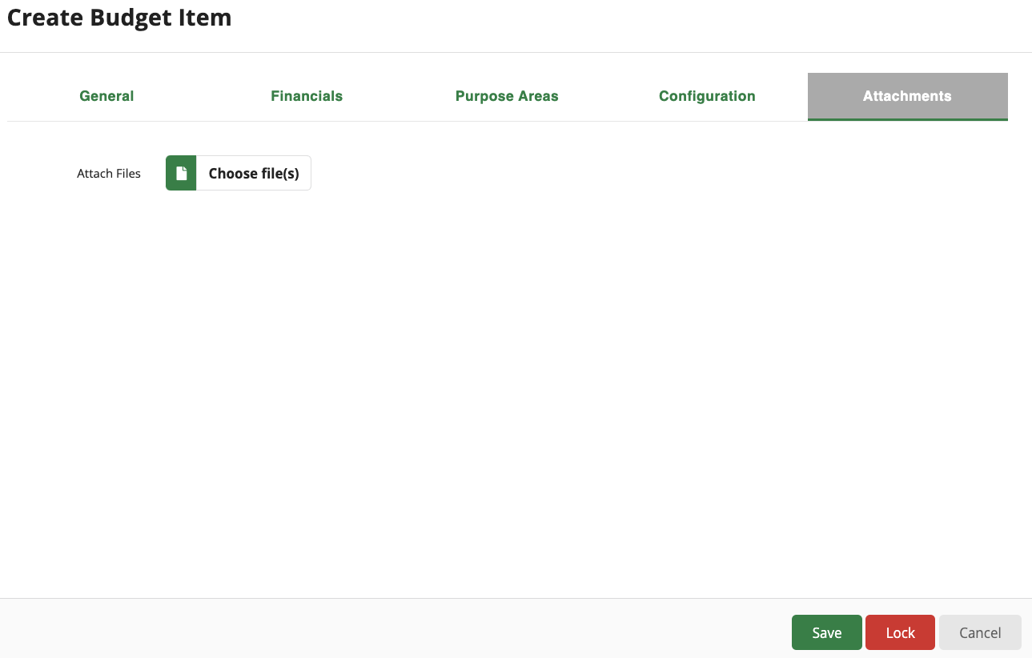

Create Uniform Grant Agreement Report

Pre-Requisites and Best Practice
The Uniform Grant Agreement Custom Forms on the Opportunity Details, Award Details, and the Custom Report must be configured to meet programmatic requirements before generating the report. The best practice is to thoroughly review the Application Material and Uniform Grant Agreement report before sending to the Grantee for signature.
Uniform Grant Agreement Creation
Complete the following steps to create the Uniform Grant Agreement.
- Click on Reports > Custom > Select the appropriate report.
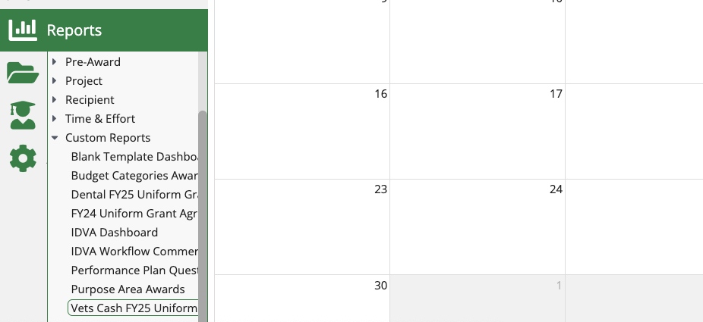
- Configure the Report Filters.
  - Click on Opportunity.Title, then select the Opportunity from the Equal To drop down.
  - Repeat this process for Awards.Name, Recipient.Name, and Opportunity Applications Info.ApplicantOrgnaization filters.
- Click Okay on the bottom center of the screen.
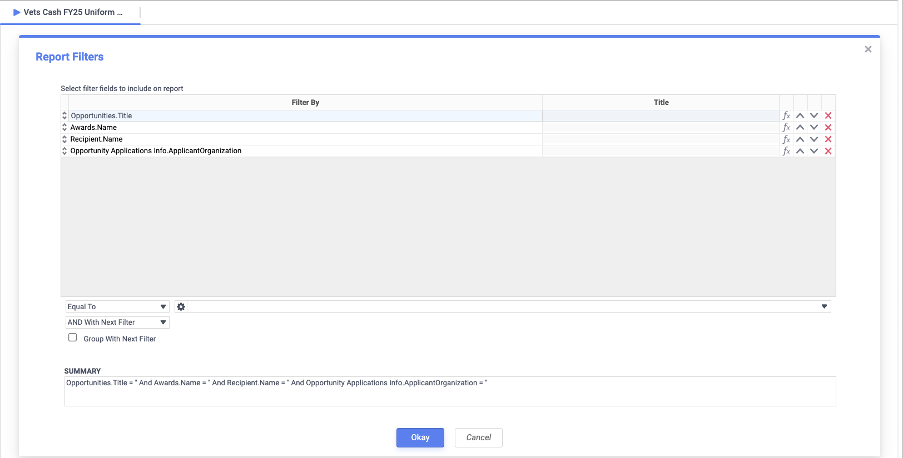
- Review the report data.
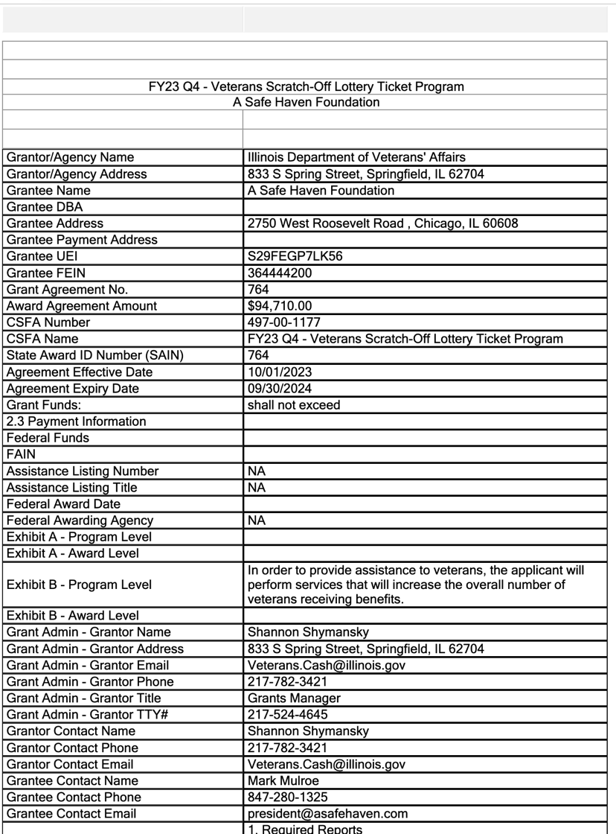
- Click Export RTF to download the Word document version of the report.
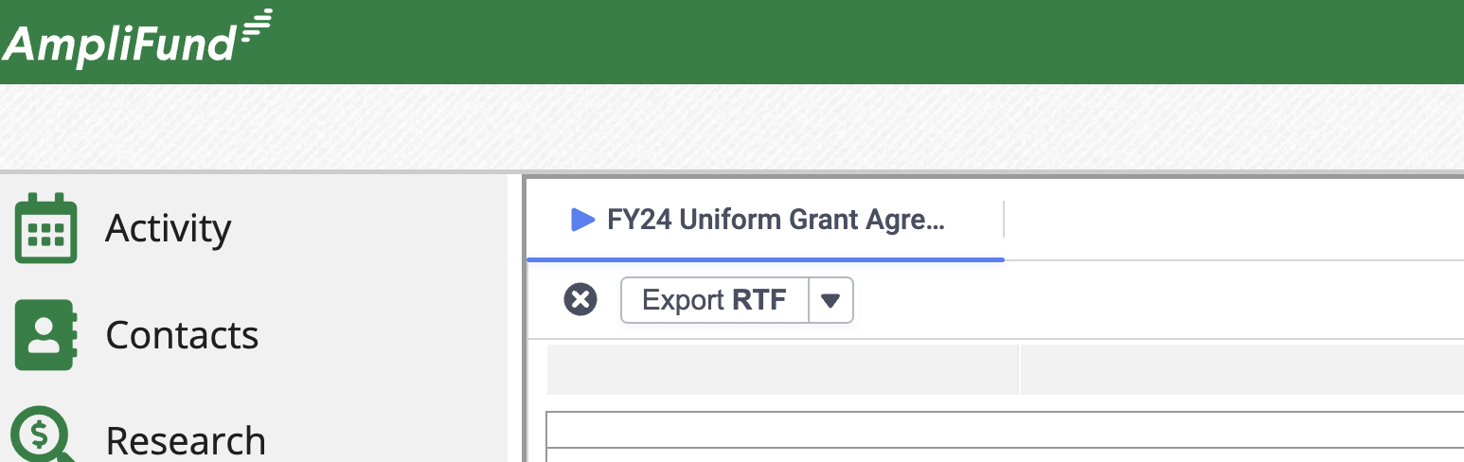
- Update the Word document as needed.
- Save the Word document.
- Send to the Grantee outside of AmpliFund for signature.
- The best practice is to upload the signed Uniform Grant Agreement to the Award through the appropriate Workflow or in the Tools > Documents > Public Folder.

Create ERP Contract

Pre-Requisites and Best Practice
All budgets and other requirements must be configured in ERP before using the ERP Integration. Using the ERP Integration does not replace ERP system requirements. Contracts are created in AmpliFund and sent to ERP through the integration. All current ERP Workflows after the Contract is created are still required. The best practice is to receive a signed Uniform Grant Agreement before creating the Contract.
Contact your AmpliFund implementation team before creating the first Contract or with any questions about the process.
Complete the following steps to access, create, and edit a Contract.
- Click on Grant Management > Grants Awarded.
- Select the Appropriate Award.
- Click on Post-Award > Management > Contracts.
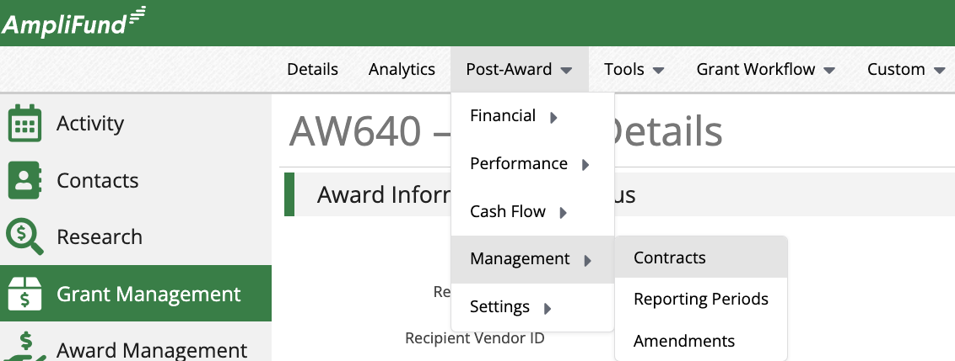
- Click on the + icon on the top right of the screen.
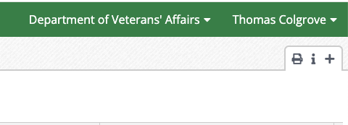
- Configure the Contract details as needed.
  - Complete the Contract section.
  - Complete the Fiscal Data section.
    - Add the Amount Per Fiscal Year.
  - Complete the Account Assignment section.
    - Add the Accounting Lines.
- Click Save on the bottom right of the screen.
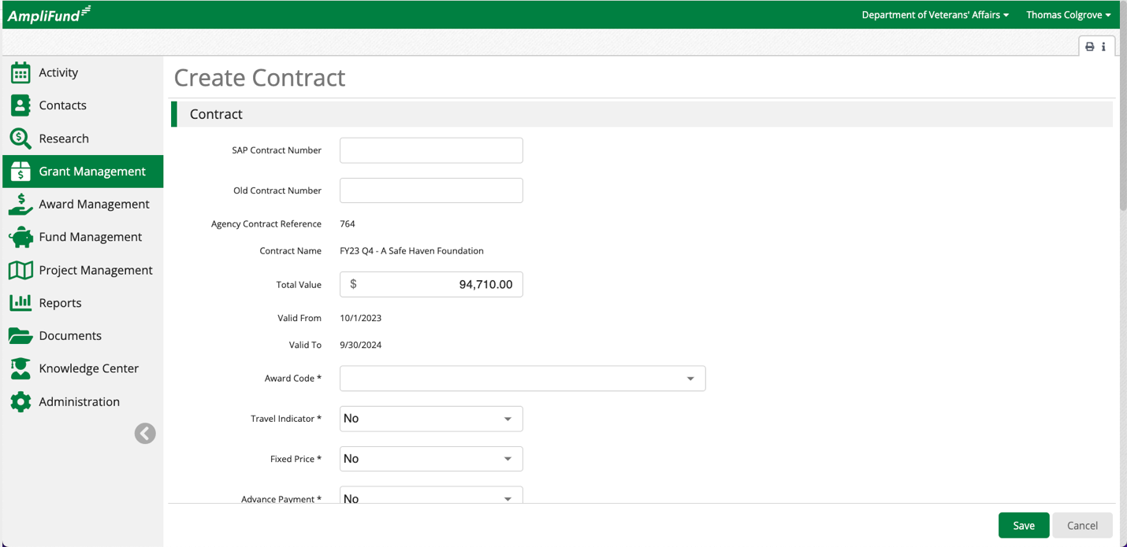
- Click the copy icon next to an existing Contract to update edit.
  - Contact your AmpliFund implementation team before editing the first Contract or with any questions about the process.
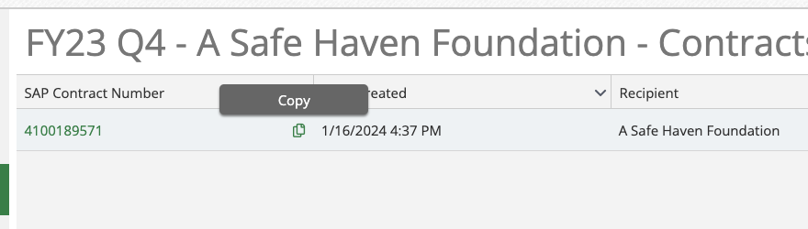

Additional ERP Resources
Create Contract Article – https://il-amplifund.zendesk.com/hc/en-us/articles/29371109976851-How-to-Create-Contracts
Edit Contract Article – https://il-amplifund.zendesk.com/hc/en-us/articles/29365340568851-Editing-a-Contract
Lunch and Learn 1 – https://il-amplifund.zendesk.com/hc/en-us/articles/14196656257043-03-03-2023-Monthly-Lunch-Learn-ERP-Contract-Creation
Lunch and Learn 2 – https://il-amplifund.zendesk.com/hc/en-us/articles/17523547329171-08-04-2023-Monthly-Lunch-Learn-Post-Award-Training-3-ERP-AP-Invoicing

Award Activation
Activate the Award to enable Grantees to access the Grant in their AmpliFund account. Ensure all communication and configuration is complete before activating the Award.
- Click on Grant Management > Grants Awarded.
- Select the appropriate Award.
- Click Activate on the bottom right of the screen.
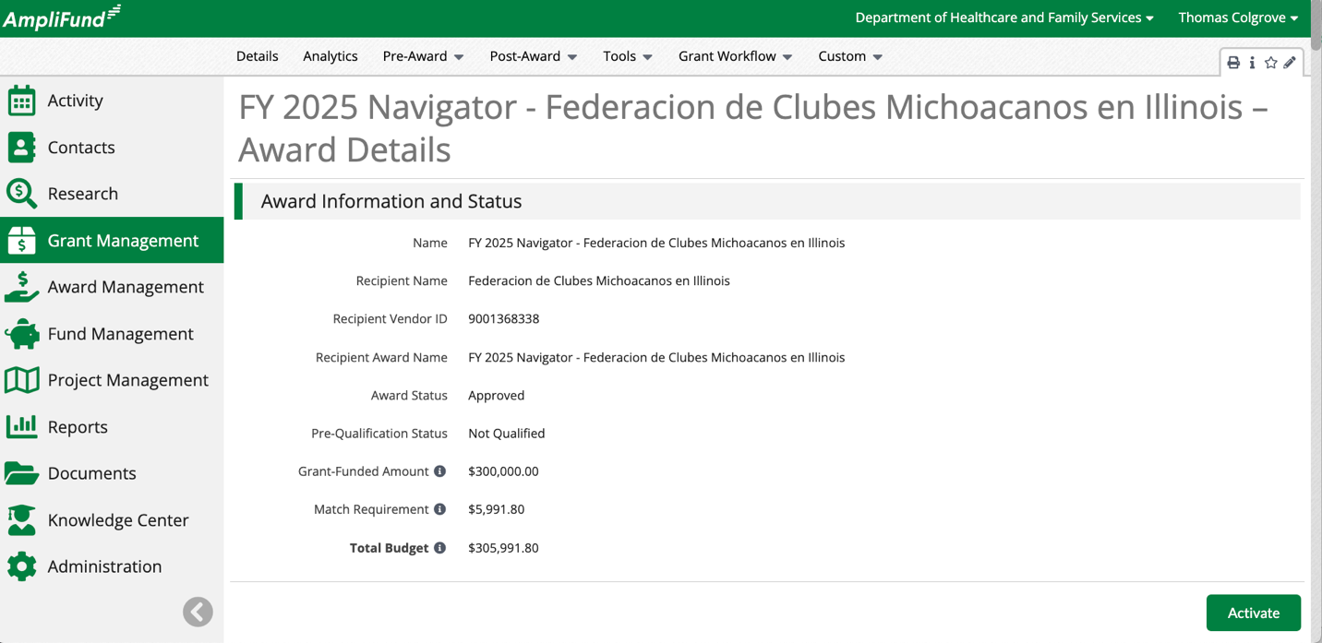

Monitoring and Reporting

Activity Center
The Activity Center offers several portfolio management tools. This document focuses on the Workflow Actions tool.
Complete the following steps to review all Workflow Actions assigned to you in the Activity Center.
- Click on Activity > Workflow Actions.
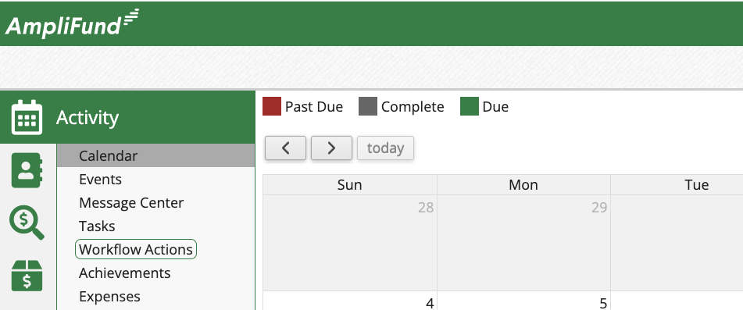
- Land on a list of all Workflow Actions.
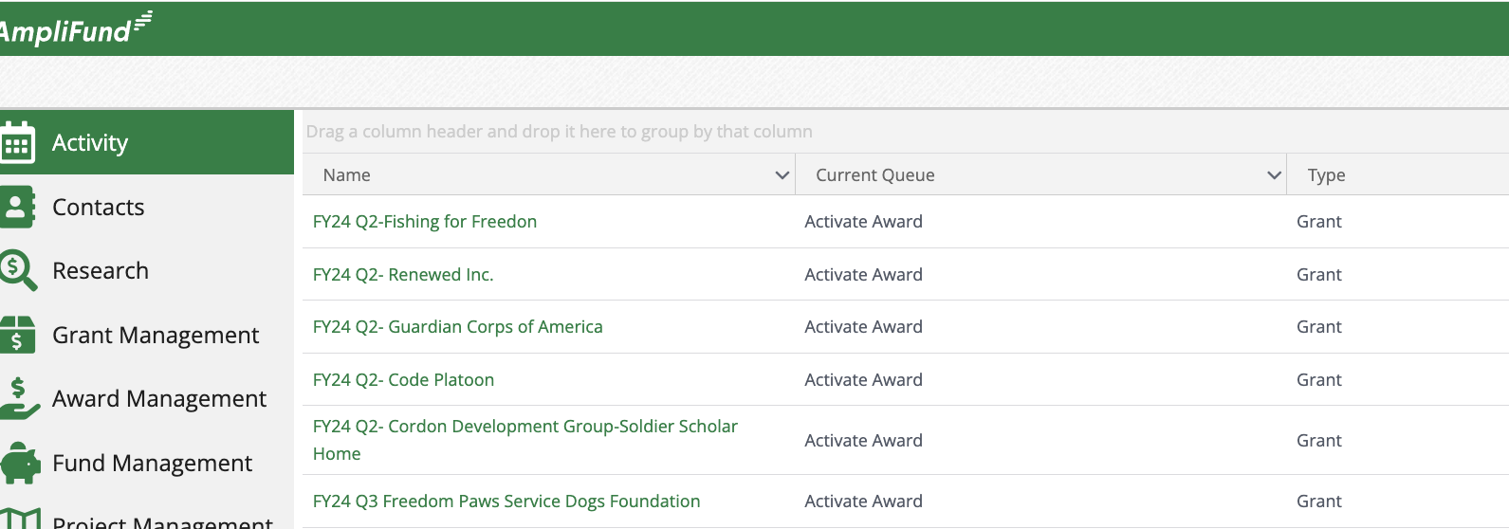

Workflow Task Completion and Item History
Review all actions taken and tasks completed against an Opportunity or Award.
Complete the following steps to access and review the Workflow Task Completion and Item History.
- Click on Award Management > Fund Opportunities.
- Select the appropriate Opportunity.
- Click on the Applications Tab.
- Select the appropriate Application.
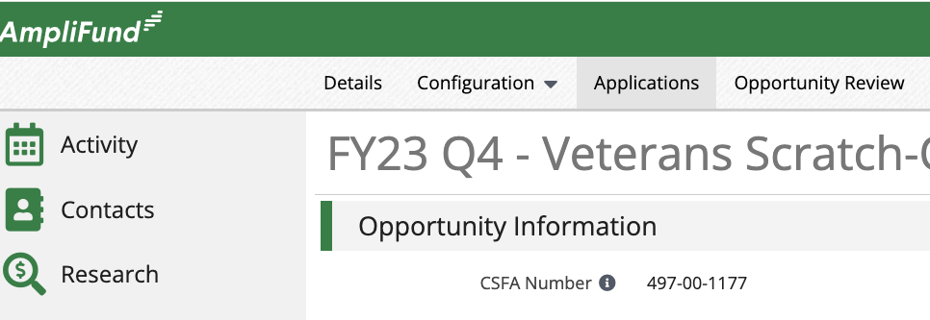
- Click on Workflow > Task Completion or Item History.
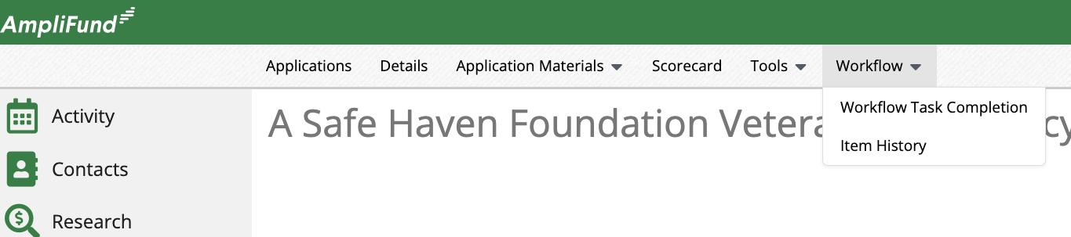

Review Award Details
The Award Details page has valuable information in each section. Review all standard Award Details and some advanced data including but not limited to Invoice and Payment data in Award Information and Status section, important dates in the Post-Award Information section, and Funding and Awarded Amount History in the Award Budget Information Section.

Analytics
The Analytics tab provides access to high level fiscal and performance data for the Award. Access the Analytics tab from the Award Details Page.
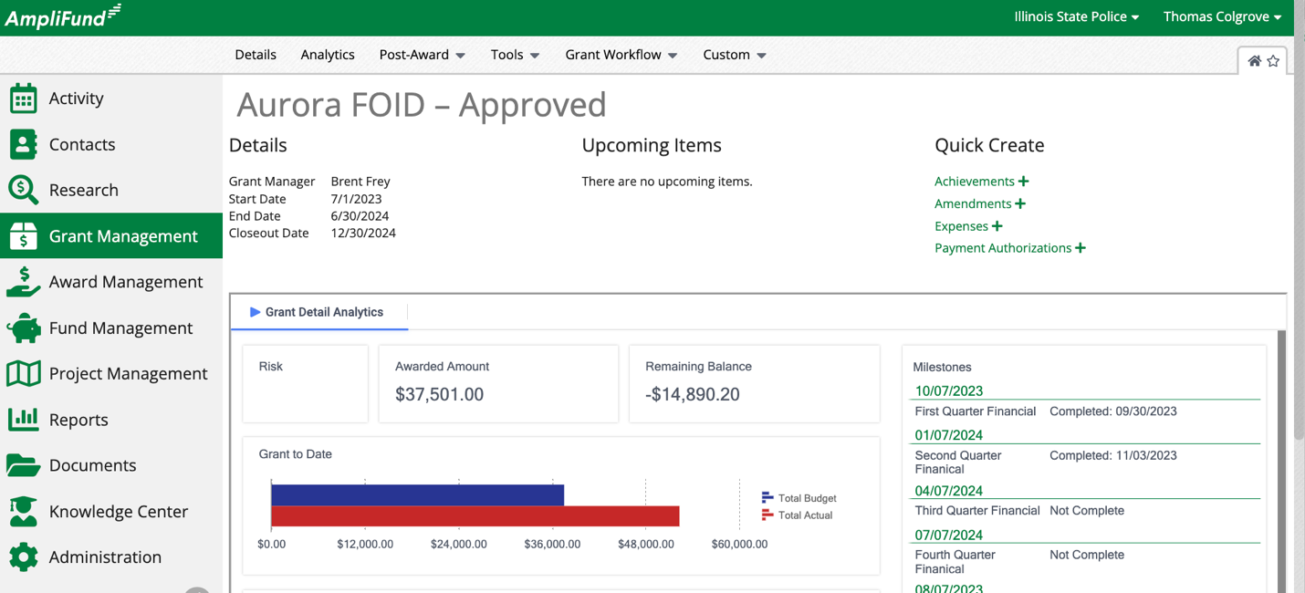

Tools and Custom
The Tools tab provides access to the Email Manager, Tasks, Documents, and Notes. Configure Custom Forms and Custom Form Extensions for the Opportunity from the Custom Tab.
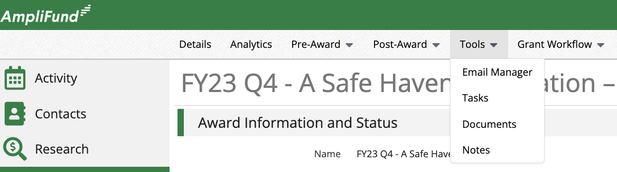
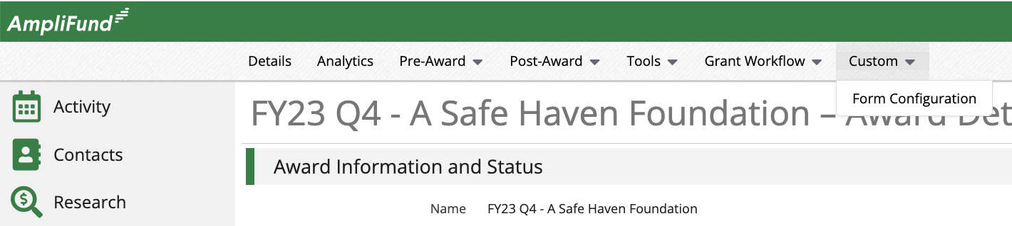

Standard Reports
Standard Reports are in all Agency accounts. Funders can report on Fund and Opportunity and Recipient Data. This document focuses on the Fund Opportunity and Scoring Report.
Complete the following steps to access and generate the Fund and Opportunity Reports.
- Click on Reports > Fund and Opportunity.
- Select the appropriate report.
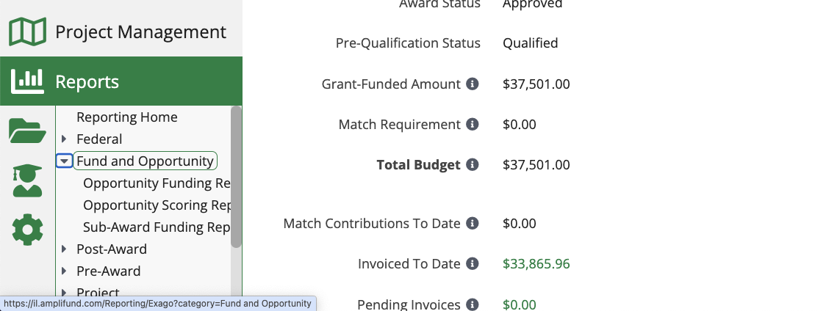
- Configure the Filters on the right side of the screen.
- Click Export on the top left of the screen to export as an Excel, PDF, RTF, or CSV.
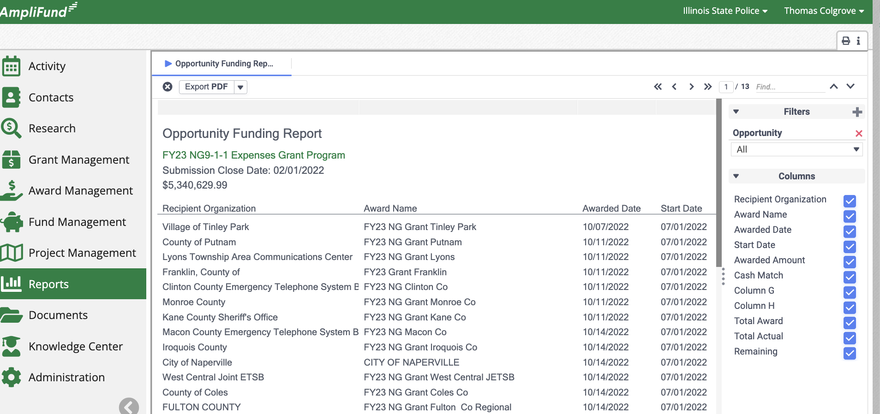

Customer Support

Housekeeping Tips
- Create an AmpliFund favorites folder in your browser.
- Follow AmpliFund Release Notes to stay up to date on product updates.
- AmpliFund Release Notes - https://il-amplifund.zendesk.com/hc/en-us/sections/360012685973-2024-Release-Notes

AmpliFund Links
- Production Link - https://il.amplifund.com
- User Acceptance Testing (UAT) Link - https://il-uat.amplifund.com

AmpliFund Support Contacts
- AmpliFund Support Site - https://il-amplifund.zendesk.com
- AmplIFund Support Email - support@il-amplifund.zendesk.com
- AmpliFund Support Phone – (844) 407-3573

GATU Support Contacts
- GATU Support Site - https://gata.illinois.gov
- GATU Support Email - omb.gata.gms@illinois.gov
- GATU Support Phone – (217)-782-4520

Glossary
- Catalogue of State Financial Assistance (CSFA) – The Catalog of State Financial Assistance (CSFA) is a single, authoritative, statewide, comprehensive source document of State financial assistance program information.
- User Acceptance Testing Environment (UAT) – A test environment for funding agencies to practice and test system functionality without impacting live production data.
- Production Environment – The live environment integrated with other State systems including the CSFA, GATA Grantee Portal, and ERP.
- License Information and Account Settings – License information and account settings can be viewed and updated by funding agencies.
- Users – Users can log into AmpliFund and create/update objects in the system based on their assigned role. All Illinois Users must have an Illinois.gov email.
- Departments - Departments can be used to link User, Grant, and Projects. The Department Admin, User (Salary), and User (No Salary) security roles have access to any record linked to their Departments.
- Subjects - Subjects are keywords that link grant and project records. By including Subjects, your Grants and Projects can be more searchable and manageable.
- Custom Budget Categories – Create custom Budget Categories that can be added to the Standard Budget Template.
- Purpose Areas - Purpose Areas offer an additional way to allocate and track grant Budgets. Multiple Purpose Areas can be added to a single Award, Grant, or Opportunity Budget Category, and Purpose Areas and be reported on globally.
- Workflow – A Workflow is a collection of Queues and Action Items used to facilitate Agency business process within AmplIFund. All Workflow Actions are tracked and can be reviewed within the system.
- Award Details - The Award Details page is where funders can access the Award Details, Grant Settings, Budget Settings, Performance Plan Settings, Budget, Performance Plan, Tools, and Workflow for a particular Award. The Post-Award review process starts on the Award Details page.
- Pre-Award Submission Information – Access submission data like the Project Information, Application Forms, Pre-Award Budget, Pre-Award Performance Plan, and Attachments.
- Award Settings – Control the Grant, Budget, and Performance Plan Settings for each Award.
- Post-Award Budget – Grantees track Expenses against the Post-Award Budget. Copy the from the Pre-Award or configure manually when creating the Award.
- Post-Award Performance Plan - Grantees track Achievements against the Post-Award Performance Plan. Copy the from the Pre-Award or configure manually when creating the Award.
- Performance Plan Goal Types – Determine the data inputs when Grantees enter Expenses. AmpliFund has the following Goal Types: Milestone, Numeric, Narrative, Percentage Achieved, Percentage Change, and Reimbursement.
- Award Activation – NOSA - There is an integration between the CSFA (Catalog of State Financial Assistance) and AmpliFund that streamlines the process. It works as follows: The funder first creates a program in the CSFA. This information is then pulled into AmpliFund when setting up the NOFO/NDFI (Opportunity). Funders can then review and select Applications to Award, and Applicants are notified of any changes to their Application Status. Once an Award is Activated in AmpliFund, the details are automatically transferred back to the CSFA. Grantees are informed of the Award Details and can access their Award by logging into AmpliFund. This integrated approach replaces the old NOSA process.
- Uniform Grant Agreement (UGA) – The standard written agreement between Illinois state funders and grantees for all programs under the GATA provision. In AmpliFund this includes the Custom Form Extensions, the latest UGA template, and a Custom Report in all accounts.
- ERP Contract – The standard fiscal agreement between Illinois state Funders and Grantees for all programs under the GATA provision. There are both AmpliFund and ERP requirements.

